Chapter 4 Problems

1, 2, 3 = straightforward, intermediate, challenging
= full solution available in Student Solutions Manual/Study Guide
= co ached solution with hints available at www.cp7e.com
= biomedical application

Section 4.1 Forces
Section 4.2 Newton’s First Law
Section 4.3 Newton’s Second Law

Section 4.4 Newton’s Third Law

1. A 6.0-kg object undergoes an acceleration of 2.0 m/s². (a) What is the magnitude of the resultant force acting on it? (b) If this same force is applied to a 4.0-kg object, what acceleration is produced?

2. A football punter accelerates a football from rest to a speed of 10 m/s during the time in which his toe is in contact with the ball (about 0.20 s). If the football has a mass of 0.50 kg, what average force does the punter exert on the ball?

3. The heaviest invertebrate is the giant squid, which is estimated to have a weight of about 2 tons spread out over its length of 70 feet. What is its weight in newtons?

4. The heaviest flying bird is the trumpeter swan, which weighs in at about 38 pounds at its heaviest. What is its weight in newtons?

5. A bag of sugar weighs 5.00 lb on Earth. What would it weigh in newtons on the Moon, where the free-fall acceleration is one-sixth that on Earth? Repeat for Jupiter, where g is 2.64 times that on Earth. Find the mass of the bag of sugar in kilograms at each of the three locations.

6. A freight train has a mass of 1.5 × 10⁷ kg. If the locomotive can exert a constant pull of 7.5 × 10⁵ N, how long does it take to increase the speed of the train from rest to 80 km/h?

7. The air exerts a forward force of 10 N on the propeller of a 0.20-kg model airplane. If the plane accelerates forward at 2.0 m/s², what is the magnitude of the resistive force exerted by the air on the airplane?

8. A 5.0-g bullet leaves the muzzle of a rifle with a speed of 320 m/s. What force (assumed constant) is exerted on the bullet while it is traveling down the 0.82-m-long barrel of the rifle?
9. A Chinook salmon has a maximum underwater speed of 3.0 m/s, and can jump out of the water vertically with a speed of 6.0 m/s. A record salmon has a length of 1.5 m and a mass of 61 kg. When swimming upward at constant speed, and neglecting buoyancy, the fish experiences three forces: an upward force F exerted by the tail fin, the downward drag force of the water, and the downward force of gravity. As the fish leaves the surface of the water, however, it experiences a net upward force causing it to acceelerate from 3.0 m/s to 6.0 m/s. Assuming that the drag force disappears as soon as the head of the fish breaks the surface and that F is exerted until 2/3 of the fish’s length has left the water, determine the magnitude of F.

10. Consider a solid metal sphere (S) a few centimeters in diameter and a feather (F). For each quantity in the list that follows, indicate whether the quantity is the same, greater, or lesser in the case of S or in that of F? Explain in each case why you gave the answer you did. Here is the list: (a) the gravitational force; (b) the time it will take to fall a given distance in air; (c) the time it will take to fall a given distance in vacuum; (d) the total force on the object when falling in vacuum.
11. A boat moves through the water with two forces acting on it. One is a 2 000-N forward push by the water on the propellor, and the other is a 1 800-N resistive force due to the water around the bow. (a) What is the acceleration of the 1000-kg boat? (b) If it starts from rest, how far will the boat move in 10.0 s? (c) What will its velocity be at the end of that time?

12. Two forces are applied to a car in an effort to move it, as shown in Figure P4.12. (a) What is the resultant of these two forces? (b) If the car has a mass of 3 000 kg, what acceleration does it have? Ignore friction.

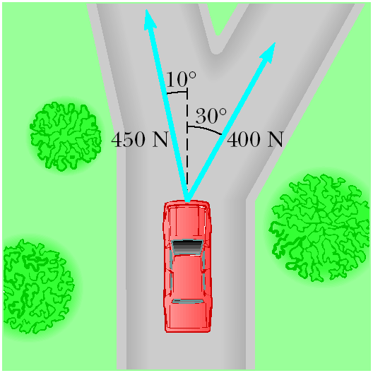
Figure P4.12

13. After falling from rest from a height of 30 m, a 0.50-kg ball rebounds upward, reaching a height of 20 m. If the contact between ball and ground lasted 2.0 ms, what average force was exerted on the ball?

14. The force exerted by the wind on the sails of a sailboat is 390 N north. The water exerts a force of 180 N east. If the boat (including its crew) has a mass of 270 kg, what are the magnitude and direction of its acceleration?

Section 4.5 Applications of Newton’s Laws

15. Find the tension in each cable supporting the 600-N cat burglar in Figure P4.15.
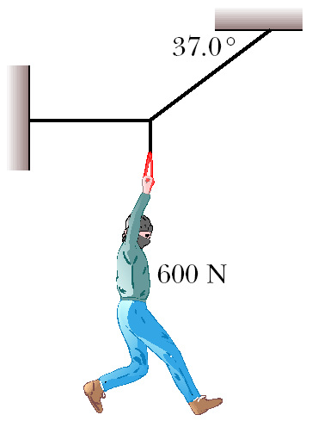
Figure P4.15

16. Find the tension in the two wires that support the 100-N light fixture in Figure P4.16.

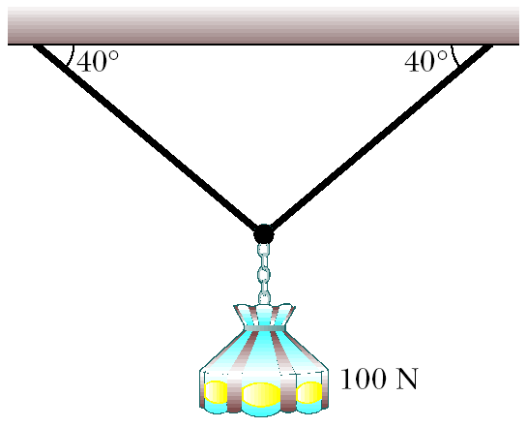
Figure P4.16

17. A 150-N bird feeder is supported by three cables as shown in Figure P4.17. Find the tension in each cable.

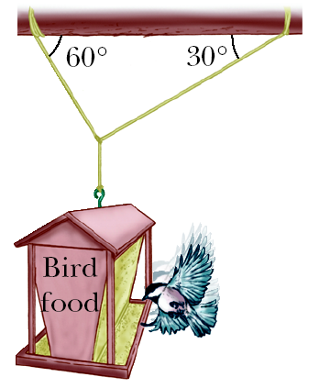
Figure P4.17
18. The leg and cast in Figure P4.18 weigh 220 N (w₁). Determine the weight w₂ and the angle α needed so that no force is exerted on the hip joint by the leg plus the cast.

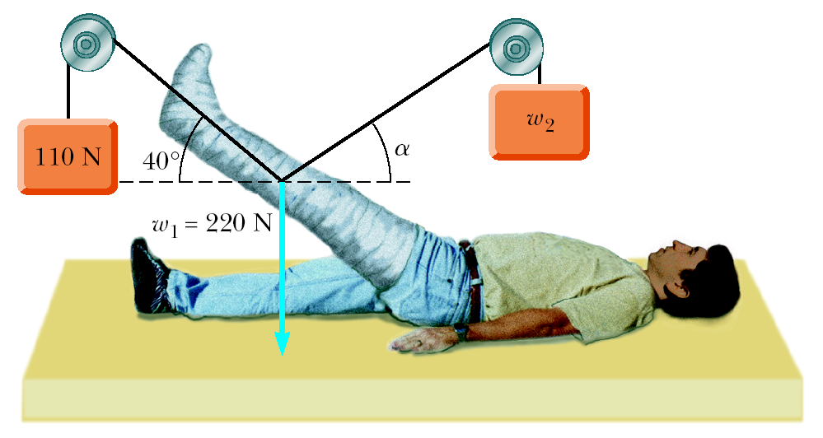
Figure P4.18

19. Two blocks are fastened to the ceiling of an elevator as in Figure P4.19. The elevator accelerates upward at 2.00 m/s². Find the tension in each rope.
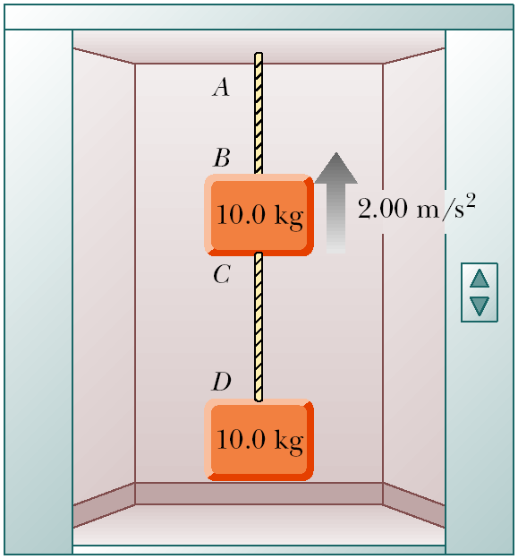
Figure P4.19

20. Two people are pulling a boat through the water as in Figure P4.20. Each exerts a force of 600 N directed at a 30.0° angle relative to the forward motion of the boat. If the boat moves with constant velocity, find the resistive force exerted by the water on the boat.

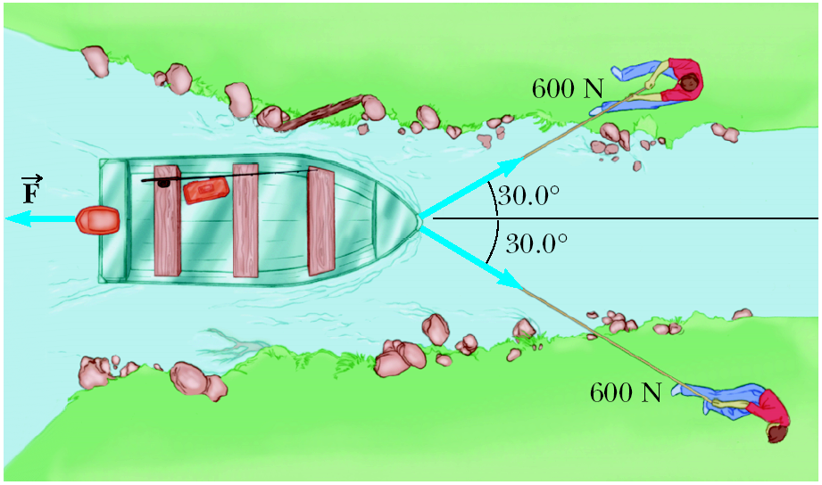
Figure P4.20

21. The distance between two telephone poles is 50.0 m. When a 1.00-kg bird lands on the telephone wire midway between the poles, the wire sags 0.200 m. Draw a free-body diagram of the bird. How much tension does the bird produce in the wire? Ignore the weight of the wire.

22. You are a judge in a children’s kite-flying contest, and two children will win prizes for the kites that pull most strongly and least strongly, respectively, on their strings. To measure string tensions, you borrow a weight hanger, some slotted weights, and a protractor from your physics teacher, and use the following protocol, illustrated in Figure P4.22: Wait for a child to get her kite well controlled, hook the hanger onto the kite string about 30 cm from her hand, pile on weight until that section of string is horizontal, record the mass required, and record the angle between the horizontal and the string running up to the kite. (a) Explain how this method works. As you construct your explanation, imagine that the children’s parents ask you about the method, that they might make false assumptions about your ability without concrete evidence, and that your explanation is an opportunity to give them confidence in your evaluation technique. (b) Find the tension in the string if the mass is 132 g and the angle is 46.3°.

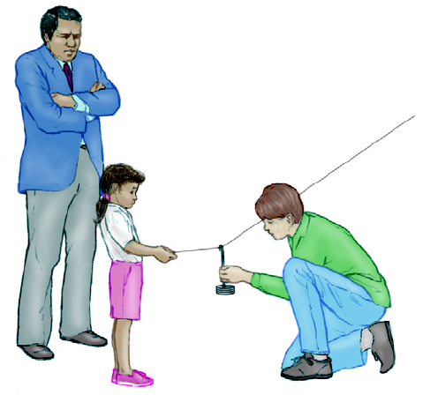
Figure P4.22
23. A 5.0-kg bucket of water is raised from a well by a rope. If the upward acceleration of the bucket is 3.0 m/s², find the force exerted by the rope on the bucket.

24. A shopper in a supermarket pushes a loaded cart with a horizontal force of 10 N. The cart has a mass of 30 kg. (a) How far will it move in 3.0 s, starting from rest? (Ignore friction.) (b) How far will it move in 3.0 s if the shopper places his 30-N child in the cart before he begins to push it?

25. A 2 000-kg car is slowed down uniformly from 20.0 m/s to 5.00 m/s in 4.00 s. (a) What average force acted on the car during that time, and (b) how far did the car travel during that time?

26. Two packing crates of masses 10.0 kg and 5.00 kg are connected by a light string that passes over a frictionless pulley as in Figure P4.26. The 5.00-kg crate lies on a smooth incline of angle 40.0°. Find the acceleration of the 5.00-kg crate and the tension in the string.

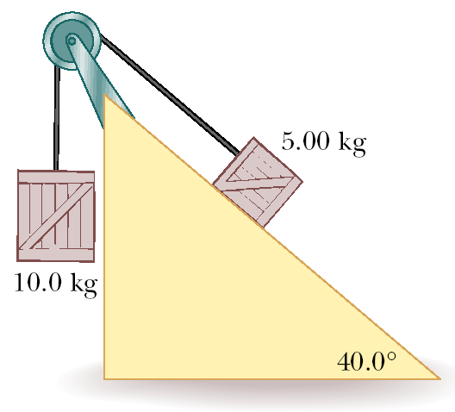
Figure P4.26

27. Assume that the three blocks portrayed in Figure P4.27 move on a frictionless surface and that a 42-N force acts as shown on the 3.0-kg block. Determine (a) the acceleration given this system, (b) the tension in the cord connecting the 3.0-kg and the 1.0-kg blocks, and (c) the force exerted by the 1.0-kg block on the 2.0-kg block.

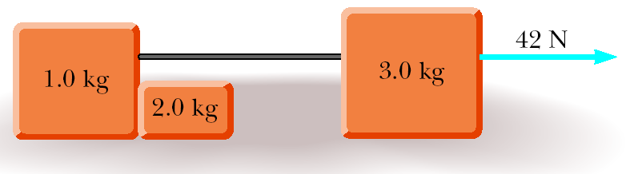
Figure P4.27

28. An object of mass 2.0 kg starts from rest and slides down an inclined plane 80 cm long in 0.50 s. What net force is acting on the object along the incline?

29. A 40.0-kg wagon is towed up a hill inclined at 18.5° with respect to the horizontal. The tow rope is parallel to the incline and has a tension of 140 N. Assume that the wagon starts from rest at the bottom of the hill, and neglect friction. How fast is the wagon going after moving 80.0 m up the hill?

30. An object with mass m₁ = 5.00 kg rests on a frictionless horizontal table and is connected to a cable that passes over a pulley and is then fastened to a hanging object with mass m₂ = 10.0 kg, as shown in Figure P4.30. Find the acceleration of each object and the tension in the cable.

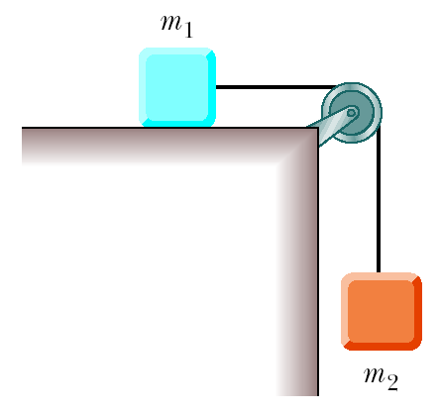
Figure P4.30 (Problems 30, 36, and 45)

31. A train has a mass of 5.22 × 10⁶ kg and is moving at 90.0 km/h. The engineer applies the brakes, resulting in a net backward force of 1.87 × 10⁶ N on the train. The brakes are held on for 30.0 s. (a) What is the final speed of the train? (b) How far does the train travel during this period?

32. (a) An elevator of mass m moving upward has two forces acting on it: the upward force of tension in the cable and the downward force due to gravity. When the elevator is accelerating upward, which is greater, T or w? (b) When the elevator is moving at a constant velocity upward, which is greater, T or w? (c) When the elevator is moving upward, but the acceleration is downward, which is greater, T or w? (d) Let the elevator have a mass of 1 500 kg and an upward acceleration of 2.5 m/s². Find T. Is your answer consistent with the answer to part (a)? (e) The elevator of part (d) now moves with a constant upward velocity of 10 m/s. Find T. Is your answer consistent with your answer to part (b)? (f) Having initially moved upward with a constant velocity, the elevator begins to accelerate downward at 1.50 m/s². Find T. Is your answer consistent with your answer to part (c)?

33. A 1 000-kg car is pulling a 300-kg trailer. Together, the car and trailer have an acceleration of 2.15 m/s² in the forward direction. Neglecting frictional forces on the trailer, determine (a) the net force on the car, (b) the net force on the trailer, (c) the force exerted by the trailer on the car, and (d) the resultant force exerted by the car on the road.

34. Two objects with masses of 3.00 kg and 5.00 kg are connected by a light string that passes over a frictionless pulley, as in Figure P4.34. Determine (a) the tension in the string, (b) the acceleration of each object, and (c) the distance each object will move in the first second of motion if both objects start from rest.

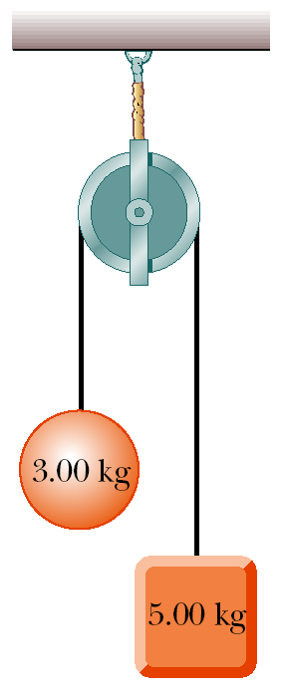
Figure P4.34

Section 4.6 Forces of Friction

35. A dockworker loading crates on a ship finds that a 20-kg crate, initially at rest on a horizontal surface, requires a 75-N horizontal force to set it in motion. However, after the crate is in motion, a horizontal force of 60 N is required to keep it moving with a constant speed. Find the coefficients of static and kinetic friction between crate and floor.

36. In Figure P4.30, m₁ = 10 kg and m₂ = 4.0 kg. The coefficient of static friction between m₁ and the horizontal surface is 0.50, and the coefficient of kinetic friction is 0.30. (a) If the system is released from rest, what will its acceleration be? (b) If the system is set in motion with m₂ moving downward, what will be the acceleration of the system?

37. A 1 000-N crate is being pushed across a level floor at a constant speed by a force of 300 N at an angle of 20.0° below the horizontal, as shown in Figure P4.37a. (a) What is the coefficient of kinetic friction between the crate and the floor? (b) If the 300-N force is instead pulling the block at an angle of 20.0° above the horizontal, as shown in Figure P4.37b, what will be the acceleration of the crate? Assume that the coefficient of friction is the same as that found in (a).

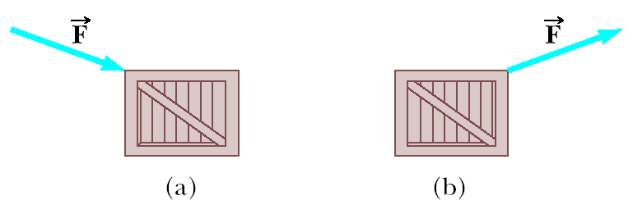
Figure P4.37

38. A hockey puck is hit on a frozen lake and starts moving with a speed of 12.0 m/s. Five seconds later, its speed is 6.00 m/s. (a) What is its average acceleration? (b) What is the average value of the coefficient of kinetic friction between puck and ice? (c) How far does the puck travel during the 5.00-s interval?

39. Consider a large truck carrying a heavy load, such as steel beams. A significant hazard for the driver is that the load may slide forward, crushing the cab, if the truck stops suddenly in an accident or even in braking. Assume, for example, that a 10 000-kg load sits on the flat bed of a 20 000-kg truck moving at 12.0 m/s. Assume the load is not tied down to the truck and has a coefficient of static friction of 0.500 with the truck bed. (a) Calculate the minimum stopping distance for which the load will not slide forward relative to the truck. (b) Is any piece of data unnecessary for the solution?

40. A woman at an airport is towing her 20.0-kg suitcase at constant speed by pulling on a strap at an angle θ above the horizontal (Fig. P4.40). She pulls on the strap with a 35.0-N force, and the friction force on the suitcase is 20.0 N. Draw a free-body diagram of the suitcase. (a) What angle does the strap make with the horizontal? (b) What normal force does the ground exert on the suitcase?

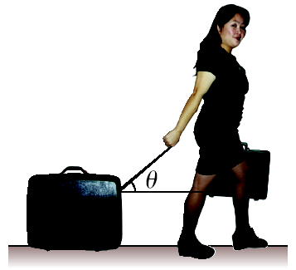
Figure P4.40

41. The coefficient of static friction between the 3.00-kg crate and the 35.0° incline of Figure P4.41 is 0.300. What minimum force must be applied to the crate perpendicular to the incline to prevent the crate from sliding down the incline?
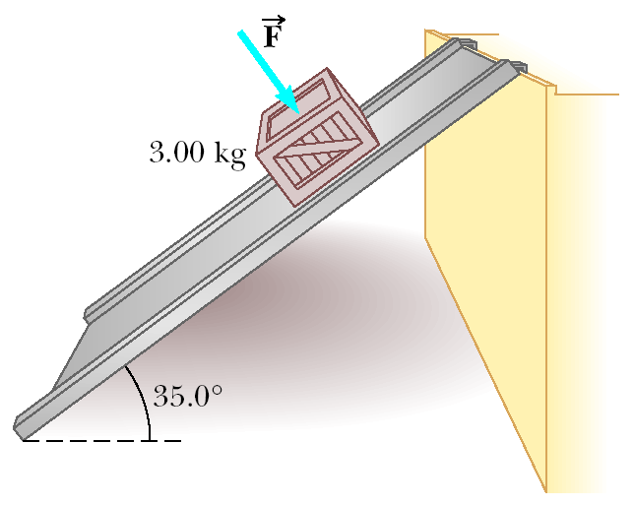
Figure P4.41

42. A box of books weighing 300 N is shoved across the floor of an apartment by a force of 400 N exerted downward at an angle of 35.2° below the horizontal. If the coefficient of kinetic friction between box and floor is 0.570, how long does it take to move the box 4.00 m, starting from rest?

43. An object falling under the pull of gravity is acted upon by a frictional force of air resistance. The magnitude of this force is approximately proportional to the speed of the object, which can be written as f = bv. Assume that b = 15 kg/s and m = 50 kg. (a) What is the terminal speed the object reaches while falling? (b) Does your answer to part (a) depend on the initial speed of the object? Explain.

44. A student decides to move a box of books into her dormitory room by pulling on a rope attached to the box. She pulls with a force of 80.0 N at an angle of 25.0° above the horizontal. The box has a mass of 25.0 kg, and the coefficient of kinetic friction between box and floor is 0.300. (a) Find the acceleration of the box. (b) The student now starts moving the box up a 10.0° incline, keeping her 80.0 N force directed at 25.0° above the line of the incline. If the coefficient of friction is unchanged, what is the new acceleration of the box?
45. Objects with masses m₁ = 10.0 kg and m₂ = 5.00 kg are connected by a light string that passes over a frictionless pulley as in Figure P4.30. If, when the system starts from rest, m₂ falls 1.00 m in 1.20 s, determine the coefficient of kinetic friction between m₁ and the table.

46. A car is traveling at 50.0 km/h on a flat highway. (a) If the coefficient of friction between road and tires on a rainy day is 0.100, what is the minimum distance in which the car will stop? (b) What is the stopping distance when the surface is dry and the coefficient of friction is 0.600?

47. A 3.00-kg block starts from rest at the top of a 30.0° incline and slides 2.00 m down the incline in 1.50 s. Find (a) the acceleration of the block, (b) the coefficient of kinetic friction between the block and the incline, (c) the frictional force acting on the block, and (d) the speed of the block after it has slid 2.00 m.

48. Objects of masses m₁ = 4.00 kg and m₂ = 9.00 kg are connected by a light string that passes over a frictionless pulley as in Figure P4.48. The object m₁ is held at rest on the floor, and m₂ rests on a fixed incline of θ = 40.0°. The objects are released from rest, and m₂ slides 1.00 m down the incline in 4.00 s. Determine (a) the acceleration of each object, (b) the tension in the string, and (c) the coefficient of kinetic friction between m₂ and the incline.

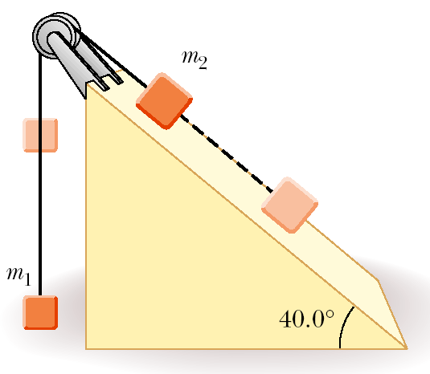
Figure P4.48

49. Find the acceleration reached by each of the two objects shown in Figure P4.49 if the coefficient of kinetic friction between the 7.00-kg object and the plane is 0.250.
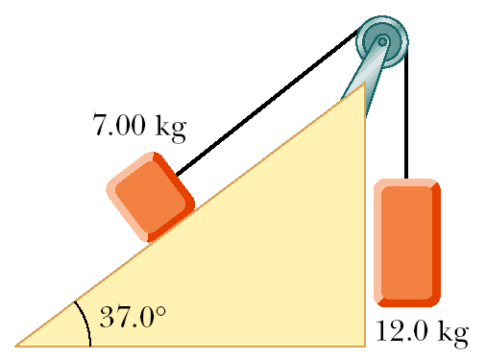
Figure P4.49

50. A 2.00-kg block is held in equilibrium on an incline of angle θ = 60.0° by a horizontal force applied in the direction shown in Figure P4.50. If the coefficient of static friction between block and incline is μ_{s} = 0.300, determine (a) the minimum value of and (b) the normal force exerted by the incline on the block.

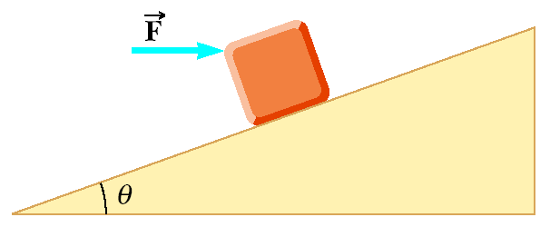
Figure P4.50
51. The person in Figure P4.51 weighs 170 lb. Each crutch makes an angle of 22.0° with the vertical (as seen from the front). Half of the person’s weight is supported by the crutches, the other half by the vertical forces exerted by the ground on his feet. Assuming that he is at rest and that the force exerted by the ground on the crutches acts along the crutches, determine (a) the smallest possible coefficient of friction between crutches and ground and (b) the magnitude of the compression force supported by each crutch.
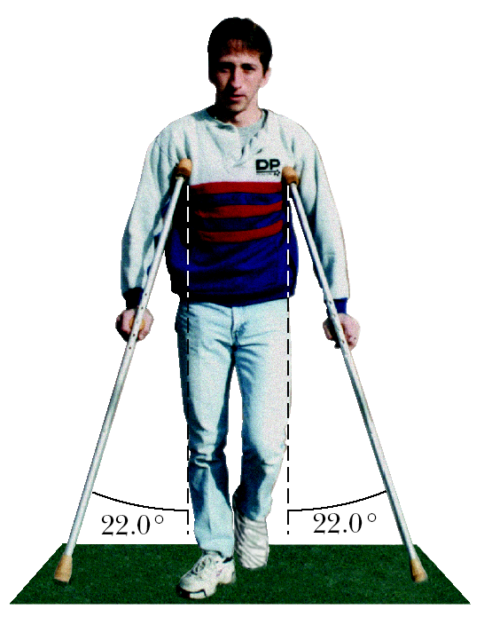
Figure P4.51

52. A block of mass m = 2.00 kg rests on the left edge of a block of length L = 3.00 m and mass M = 8.00 kg. The coefficient of kinetic friction between the two blocks is μ_{k} = 0.300, and the surface on which the 8.00-kg block rests is frictionless. A constant horizontal force of magnitude F = 10.0 N is applied to the 2.00-kg block, setting it in motion as shown in Figure P4.52a. (a) How long will it take before this block makes it to the right side of the 8.00-kg block, as shown in Figure P4.52b? (Note: Both blocks are set in motion when the force is applied.) (b) How far does the 8.00-kg block move in the process?
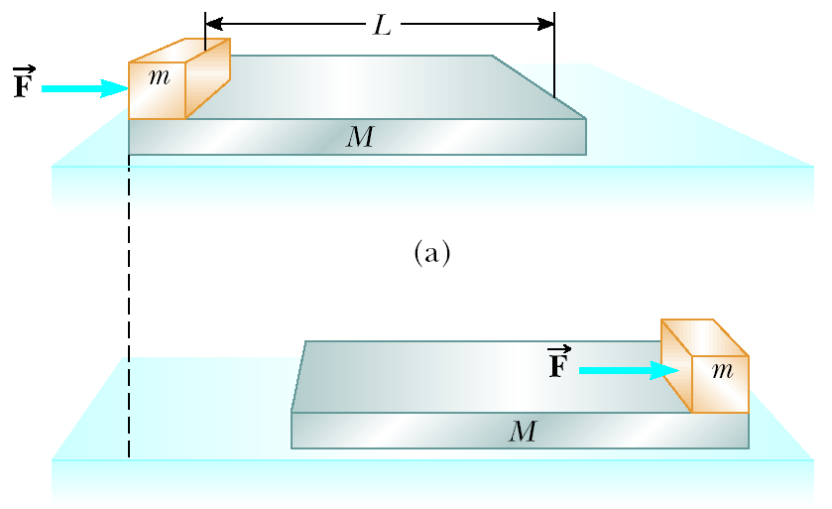
Figure P4.52

Additional Problems

53. In Figure P4.53, the coefficient of kinetic friction between the two blocks shown is 0.30. The surface of the table and the pulleys are frictionless. (a) Draw a free-body diagram for each block. (b) Determine the acceleration of each block. (c) Find the tension in the strings.

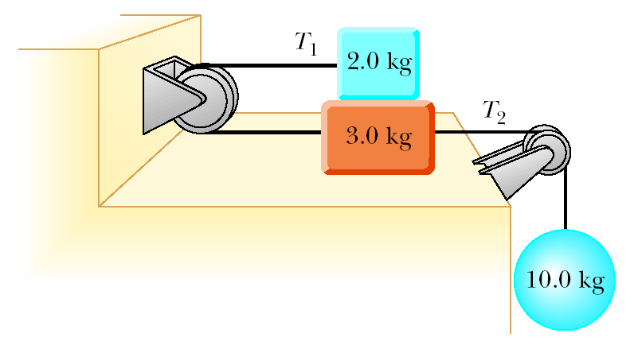
Figure P4.53

54. The force exerted by the wind on a sailboat is approximately perpendicular to the sail and proportional to the component of the wind velocity perpendicular to the sail. For the 800 kg sailboat shown in Figure P4.54, the proportionality constant is

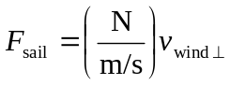

Water exerts a force along the keel (bottom) of the boat that prevents it from moving sideways, as shown in the figure. Once the boat starts moving forward, water also exerts a drag force backwards on the boat, opposing the forward motion. If a 17-knot wind (1 knot = 0.514 m/s) is blowing to the east, what is the initial acceleration of the sailboat?

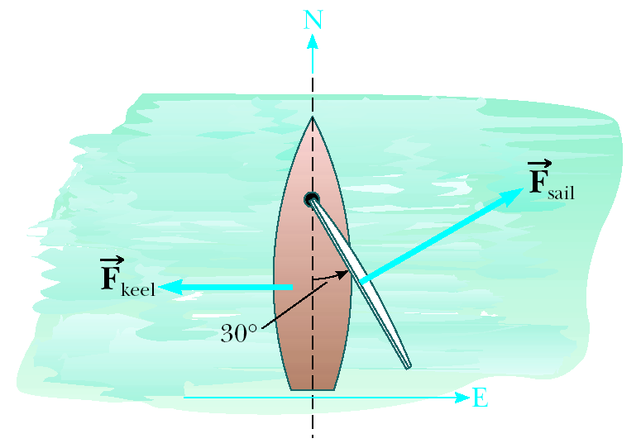
Figure P4.54

55. (a) What is the resultant force exerted by the two cables supporting the traffic light in Figure P4.55? (b) What is the weight of the light?

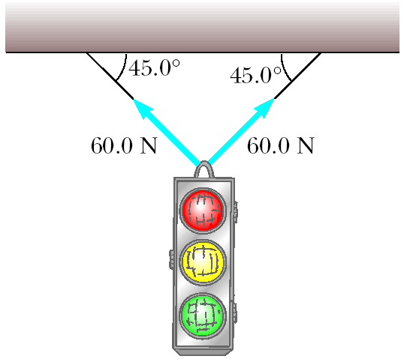
Figure P4.55

56. As a protest against the umpire’s calls, a baseball pitcher throws a ball straight up into the air at a speed of 20.0 m/s. In the process, he moves his hand through a distance of 1.50 m. If the ball has a mass of 0.150 kg, find the force he exerts on the ball to give it this upward speed.

57. A boy coasts down a hill on a sled, reaching a level surface at the bottom with a speed of 7.0 m/s. If the coefficient of friction between the sled’s runners and the snow is 0.050 and the boy and sled together weigh 600 N, how far does the sled travel on the level surface before coming to rest?

58. (a) What is the minimum force of friction required to hold the system of Figure P4.58 in equilibrium? (b) What coefficient of static friction between the 100-N block and the table ensures equilibrium? (c) If the coefficient of kinetic friction between the 100-N block and the table is 0.250, what hanging weight should replace the 50.0-N weight to allow the system to move at a constant speed once it is set in motion?

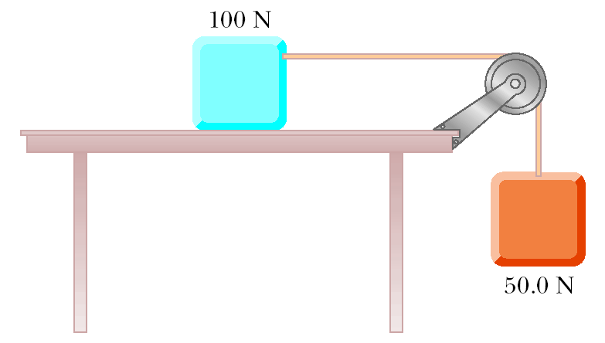
Figure P4.58

59. A box rests on the back of a truck. The coefficient of static friction between the box and the bed of the truck is 0.300. (a) When the truck accelerates forward, what force accelerates the box? (b) Find the maximum acceleration the truck can have before the box slides.

60. A 4.00-kg block is pushed along the ceiling with a constant applied force of 85.0 N that acts at an angle of 55.0° with the horizontal, as in Figure P4.60. The block accelerates to the right at 6.00 m/s². Determine the coefficient of kinetic friction between block and ceiling.

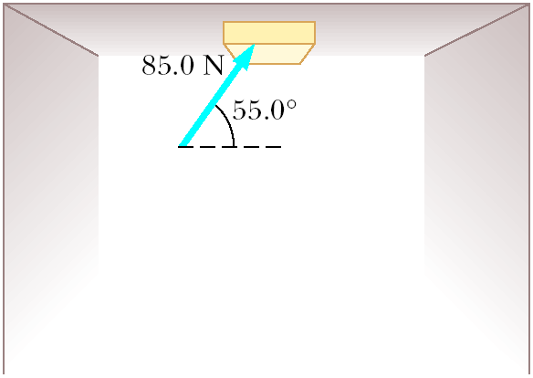
Figure P4.60

61. A frictionless plane is 10.0 m long and inclined at 35.0°. A sled starts at the bottom with an initial speed of 5.00 m/s up the incline. When the sled reaches the point at which it momentarily stops, a second sled is released from the top of the incline with an initial speed v_{i}. Both sleds reach the bottom of the incline at the same moment. (a) Determine the distance that the first sled traveled up the incline. (b) Determine the initial speed of the second sled.

62. Three objects are connected by light strings as shown in Figure P4.62. The string connecting the 4.00-kg object and the 5.00-kg object passes over a light frictionless pulley. Determine (a) the acceleration of each object and (b) the tension in the two strings.

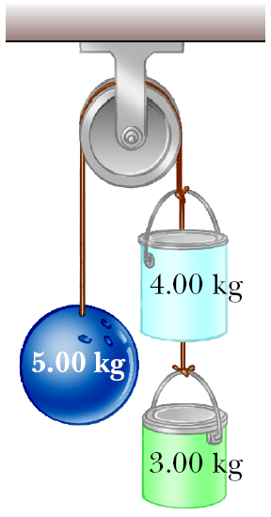
Figure P4.62

63. A 2.00-kg aluminum block and a 6.00-kg copper block are connected by a light string over a frictionless pulley. The two blocks are allowed to move on a fixed steel block wedge (of angle θ = 30.0°) as shown in Figure P4.63. Making use of Table 4.2, determine (a) the acceleration of the two blocks and (b) the tension in the string.
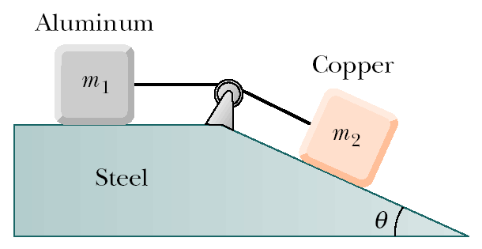
Figure P4.63

64. A 5.0-kg penguin sits on a 10-kg sled, as shown in Figure P4.64. A horizontal force of 45 N is applied to the sled, but the penguin attempts to impede the motion by holding onto a cord attached to a wall. The coefficient of kinetic friction between the sled and the snow, as well as that between the sled and the penguin, is 0.20. (a) Draw a free-body diagram for the penguin and one for the sled, and identify the reaction force for each force you include. Determine (b) the tension in the cord and (c) the acceleration of the sled.

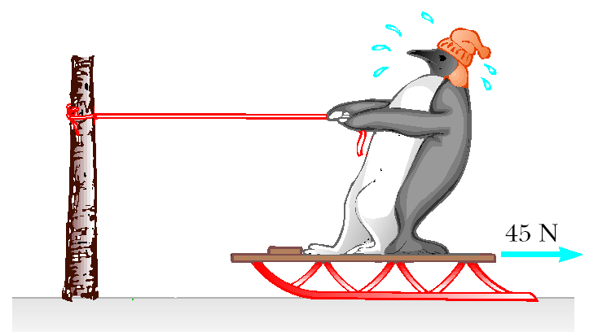
Figure P4.64

65. Two boxes of fruit on a frictionless horizontal surface are connected by a light string as in Figure P4.65, where m₁ = 10 kg and m₂ = 20 kg. A force of 50 N is applied to the 20-kg box. (a) Determine the acceleration of each box and the tension in the string. (b) Repeat the problem for the case where the coefficient of kinetic friction between each box and the surface is 0.10.
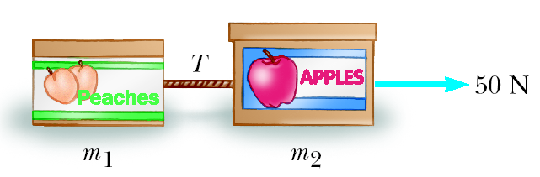
Figure P4.65

66. A high diver of mass 70.0 kg jumps off a board 10.0 m above the water. If her downward motion is stopped 2.00 s after she enters the water, what average upward force did the water exert on her?

67. Two people pull as hard as they can on ropes attached to a 200-kg boat. If they pull in the same direction, the boat has an acceleration of 1.52 m/s² to the right. If they pull in opposite directions, the boat has an acceleration of 0.518 m/s² to the left. What is the force exerted by each person on the boat? (Disregard any other forces on the boat.)

68. A 3.0-kg object hangs at one end of a rope that is attached to a support on a railroad car. When the car accelerates to the right, the rope makes an angle of 4.0° with the vertical, as shown in Figure P4.68. Find the acceleration of the car.
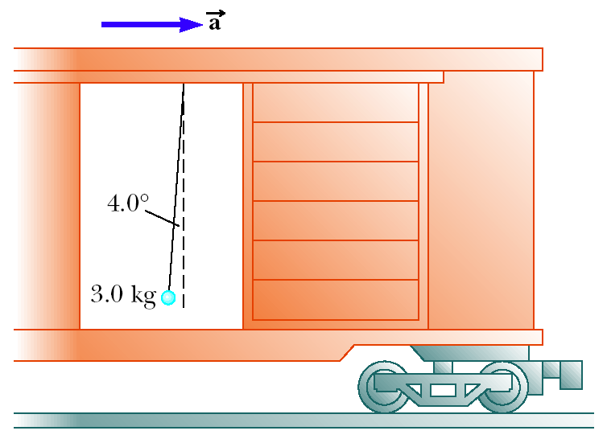
Figure P4.68

69. Three blocks of masses 10.0 kg, 5.00 kg, and 3.00 kg are connected by light strings that pass over frictionless pulleys as shown in Figure P4.69. The acceleration of the 5.00-kg block is 2.00 m/s² to the left, and the surfaces are rough. Find (a) the tension in each string and (b) the coefficient of kinetic friction between blocks and surfaces. (Assume the same μ_{k} for both blocks that are in contact with surfaces.)

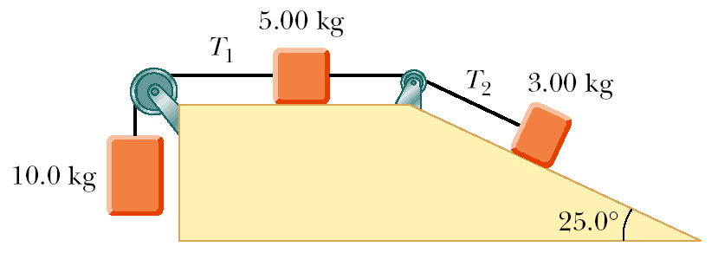
Figure P4.69

70. An inquisitive physics student, wishing to combine pleasure with scientific inquiry, rides on a rollercoaster sitting on a bathroom scale. (Do not try this yourself on a roller coaster that forbids loose heavy packages.) The bottom of the seat in the rollercoaster car is in a plane parallel to the track. The seat has a perpendicular back and a seat belt that fits around the student’s chest in a plane parallel to the bottom of the seat. The student lifts his feet from the floor, so that the scale reads his weight, 200 lb, when the car is horizontal. At one point during the ride, the car zooms with negligible friction down a straight slope inclined at 30.0° below the horizontal. What does the scale read at that point?

71. A van accelerates down a hill (Fig. P4.71), going from rest to 30.0 m/s in 6.00 s. During the acceleration, a toy (m = 0.100 kg) hangs by a string from the van’s ceiling. The acceleration is such that the string remains perpendicular to the ceiling. Determine (a) the angle θ and (b) the tension in the string.

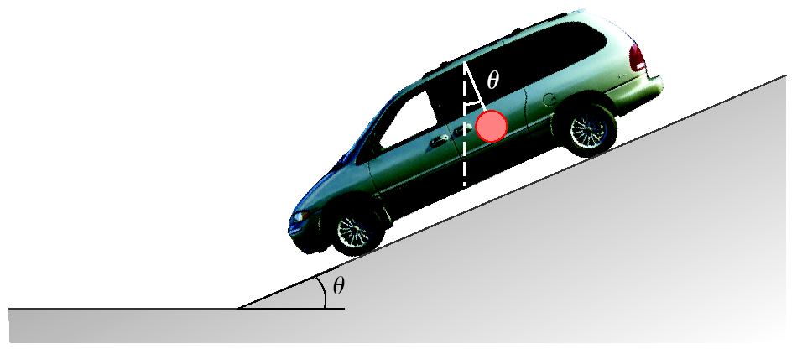
Figure P4.71

72. An 80-kg stuntman jumps from a window of a building situated 30 m above a catching net. Assuming that air resistance exerts a 100-N force on the stuntman as he falls, determine his velocity just before he hits the net.

73. The parachute on a race car of weight 8 820 N opens at the end of a quarter-mile run when the car is traveling at 35 m/s. What total retarding force must be supplied by the parachute to stop the car in a distance of 1 000 m?
74. On an airplane’s takeoff, the combined action of the air around the engines and wings of an airplane exerts an 8 000-N force on the plane, directed upward at an angle of 65.0° above the horizontal. The plane rises with constant velocity in the vertical direction while continuing to accelerate in the horizontal direction. (a) What is the weight of the plane? (b) What is its horizontal acceleration?

75. A 72-kg man stands on a spring scale in an elevator. Starting from rest, the elevator ascends, attaining its maximum speed of 1.2 m/s in 0.80 s. The elevator travels with this constant speed for 5.0 s, undergoes a uniform negative acceleration for 1.5 s, and then comes to rest. What does the spring scale register (a) before the elevator starts to move? (b) during the first 0.80 s of the elevator’s ascent? (c) while the elevator is traveling at constant speed? (d) during the elevator’s negative acceleration?

76. A sled weighing 60.0 N is pulled horizontally across snow so that the coefficient of kinetic friction between sled and snow is 0.100. A penguin weighing 70.0 N rides on the sled, as in Figure P4.76. If the coefficient of static friction between penguin and sled is 0.700, find the maximum horizontal force that can be exerted on the sled before the penguin begins to slide off.

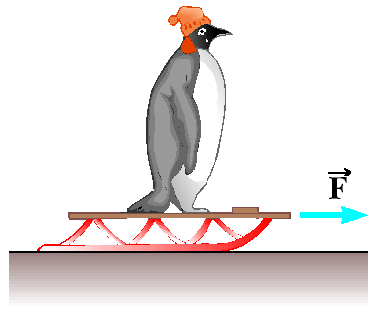
Figure P4.76

77. The board sandwiched between two other boards in Figure P4.77 weighs 95.5 N. If the coefficient of friction between the boards is 0.663, what must be the magnitude of the compression forces (assumed to be horizontal) acting on both sides of the center board to keep it from slipping?

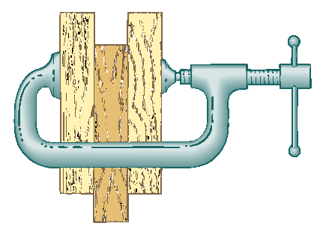
Figure P4.77

78. A magician pulls a tablecloth from under a 200-g mug located 30.0 cm from the edge of the cloth. The cloth exerts a friction force of 0.100 N on the mug and is pulled with a constant acceleration of 3.00 m/s². How far does the mug move relative to the horizontal tabletop before the cloth is completely out from under it? Note that the cloth must move more than 30 cm relative to the tabletop during the process.

79. An inventive child wants to reach an apple in a tree without climbing the tree. Sitting in a chair connected to a rope that passes over a frictionless pulley (Fig. P4.79), the child pulls on the loose end of the rope with such a force that the spring scale reads 250 N. The child’s true weight is 320 N, and the chair weighs 160 N. (a) Show that the acceleration of the system is upward and find its magnitude. (b) Find the force the child exerts on the chair.

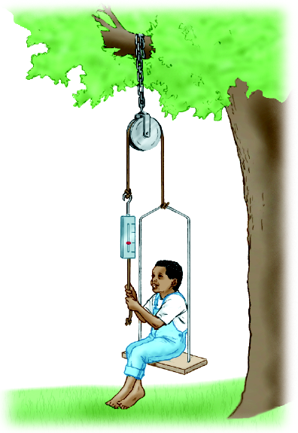
Figure P4.79

80. A fire helicopter carries a 620-kg bucket of water at the end of a 20.0-m-long cable. Flying back from a fire at a constant speed of 40.0 m/s, the cable makes an angle of 40.0° with respect to the vertical. Determine the force exerted by air resistance on the bucket.

81. A bag of cement hangs from three wires as shown in Figure P4.81. Two of the wires make angles θ₁ and θ₂, respectively, with the horizontal. (a) Show that, if the system is in equilibrium, then

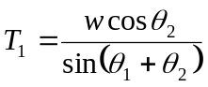

(b) Given that w = 325 N, θ₁ = 10.0°, and θ₂ = 25.0°, find the tensions T₁, T₂, and T₃ in the wires.

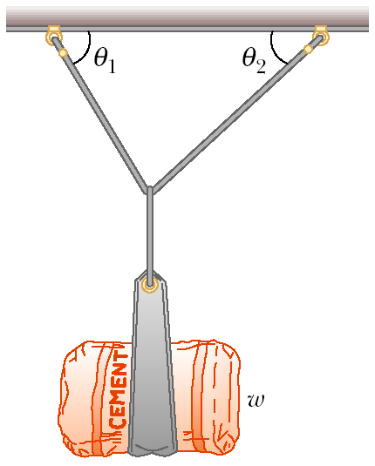
Figure P4.81

© Copyright 2004 Thomson. All rights reserved

