Chapter 6 Problems

1, 2, 3 = straightforward, intermediate, challenging
= full solution available in Student Solutions Manual/Study Guide
= co ached solution with hints available at www.cp7e.com
= biomedical application

Section 6.1 Momentum and Impulse

1. A ball of mass 0.150 kg is dropped from rest from a height of 1.25 m. It rebounds from the floor to reach a height of 0.960 m. What impulse was given to the ball by the floor?

2. A tennis player receives a shot with the ball (0.060 0 kg) traveling horizontally at 50.0 m/s and returns the shot with the ball traveling horizontally at 40.0 m/s in the opposite direction. (a) What is the impulse delivered to the ball by the racquet? (b) What work does the racquet do on the ball?

3. Calculate the magnitude of the linear momentum for the following cases: (a) a proton with mass 1.67 × 10^{–27} kg, moving with a speed of 5.00 × 10⁶ m/s; (b) a 15.0-g bullet moving with a speed of 300 m/s; (c) a 75.0-kg sprinter running with a speed of 10.0 m/s; (d) the Earth (mass = 5.98 × 10²⁴ kg) moving with an orbital speed equal to 2.98 × 10⁴ m/s.

4. A 0.10-kg ball is thrown straight up into the air with an initial speed of 15 m/s. Find the momentum of the ball (a) at its maximum height and (b) halfway to its maximum height.

5. A pitcher claims he can throw a 0.145-kg baseball with as much momentum as a 3.00-g bullet moving with a speed of 1.50 × 10³ m/s. (a) What must the baseball’s speed be if the pitcher’s claim is valid? (b) Which has greater kinetic energy, the ball or the bullet?

6. A stroboscopic photo of a club hitting a golf ball, such as the photo shown in Figure 6.3, was made by Harold Edgerton in 1933. The ball was initially at rest, and the club was shown to be in contact with the club for about 0.002 0 s. Also, the ball was found to end up with a speed of 2.0 × 10² ft/s. Assuming that the golf ball had a mass of 55 g, find the average force exerted by the club on the ball.
7. A professional diver performs a dive from a platform 10 m above the water surface. Estimate the order of magnitude of the average impact force she experiences in her collision with the water. State the quantities you take as data and their values.

8. A 75.0-kg stuntman jumps from a balcony and falls 25.0 m before colliding with a pile of mattresses. If the mattresses are compressed 1.00 m before he is brought to rest, what is the average force exerted by the mattresses on the stuntman?

9. A car is stopped for a traffic signal. When the light turns green, the car accelerates, increasing its speed from 0 to 5.20 m/s in 0.832 s. What are the magnitudes of the linear impulse and the average total force experienced by a 70.0-kg passenger in the car during the time the car accelerates?

10. A 0.500-kg football is thrown toward the east with a speed of 15.0 m/s. A stationary receiver catches the ball and brings it to rest in 0.020 0 s. (a) What is the impulse delivered to the ball as it’s caught? (b) What is the average force exerted on the receiver?

11. The force shown in the force vs. time diagram in Figure P6.11 acts on a 1.5-kg object. Find (a) the impulse of the force, (b) the final velocity of the object if it is initially at rest, and (c) the final velocity of the object if it is initially moving along the x-axis with a velocity of –2.0 m/s.

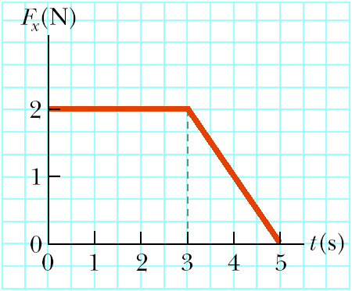
Figure P6.11

12. A force of magnitude F_{x} acting in the x-direction on a 2.00-kg particle varies in time as shown in Figure P6.12. Find (a) the impulse of the force, (b) the final velocity of the particle if it is initially at rest, and (c) the final velocity of the particle if it is initially moving along the x-axis with a velocity of
–2.00 m/s.

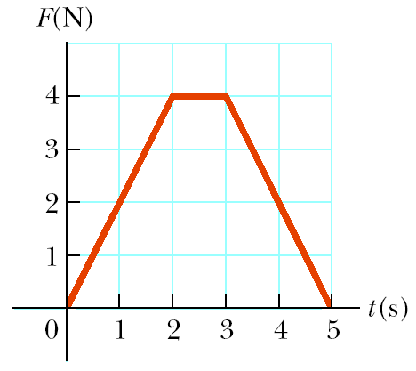
Figure P6.12

13. The forces shown in the force vs. time diagram in Figure P6.13 act on a 1.5-kg particle. Find (a) the impulse for the interval from t = 0 to t = 3.0 s and (b) the impulse for the interval from t = 0 to t = 5.0 s. (c) If the forces act on a 1.5-kg particle that is initially at rest, find the particle’s speed at t = 3.0 s and at t = 5.0 s.

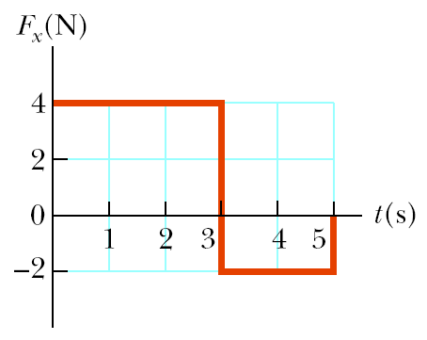
Figure P6.13

14. A 3.00-kg steel ball strikes a massive wall at 10.0 m/s at an angle of 60.0° with the plane of the wall. It bounces off the wall with the same speed and angle (Fig. P6.14). If the ball is in contact with the wall for 0.200 s, what is the average force exerted by the wall on the ball?

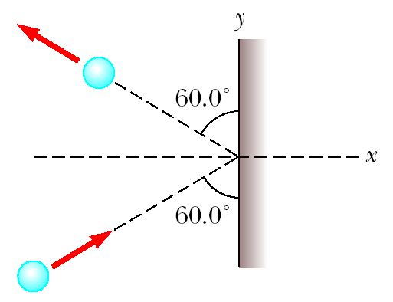
Figure P6.14

15. The front 1.20 m of a 1 400-kg car is designed as a “crumple zone” that collapses to absorb the shock of a collision. If a car traveling 25.0 m/s stops uniformly in 1.20 m, (a) how long does the collision last, (b) what is the magnitude of the average force on the car, and (c) what is the acceleration of the car? Express the acceleration as a multiple of the acceleration of gravity.

16. A pitcher throws a 0.15-kg baseball so that it crosses home plate horizontally with a speed of 20 m/s. The ball is hit straight back at the pitcher with a final speed of 22 m/s. (a) What is the impulse delivered to the ball? (b) Find the average force exerted by the bat on the ball if the two are in contact for 2.0 × 10^{–3} s.

17. A car of mass 1.6 × 10³ kg is traveling east at a speed of 25 m/s along a horizontal roadway. When its brakes are applied, the car stops in 6.0 s. What is the average horizontal force exerted on the car while it is braking?

Section 6.2 Conservation of Momentum

18. A 730-N man stands in the middle of a frozen pond of radius 5.0 m. He is unable to get to the other side because of a lack of friction between his shoes and the ice. To overcome this difficulty, he throws his 1.2-kg physics textbook horizontally toward the north shore at a speed of 5.0 m/s. How long does it take him to reach the south shore?

19. High-speed stroboscopic photographs show that the head of a 200-g golf club is traveling at 55 m/s just before it strikes a 46-g golf ball at rest on a tee. After the collision, the club head travels (in the same direction) at 40 m/s. Find the speed of the golf ball just after impact.

20. A rifle with a weight of 30 N fires a 5.0-g bullet with a speed of 300 m/s. (a) Find the recoil speed of the rifle. (b) If a 700-N man holds the rifle firmly against his shoulder, find the recoil speed of the man and rifle.
21. A 45.0-kg girl is standing on a 150-kg plank. The plank, originally at rest, is free to slide on a frozen lake, which is a flat, frictionless surface. The girl begins to walk along the plank at a constant velocity of 1.50 m/s to the right relative to the plank. (a) What is her velocity relative to the surface of the ice? (b) What is the velocity of the plank relative to the surface of the ice?

22. A 65.0-kg person throws a 0.045 0-kg snowball forward with a ground speed of 30.0 m/s. A second person, with a mass of 60.0 kg, catches the snowball. Both people are on skates. The first person is initially moving forward with a speed of 2.50 m/s, and the second person is initially at rest. What are the velocities of the two people after the snowball is exchanged? Disregard friction between the skates and the ice.

23. In Section 6.2, we implied that the kinetic energy of the Earth can be ignored when considering the energy of a system consisting of the Earth and a dropped ball of mass m_{b}. Verify this statement by first setting up a ratio of the kinetic energy of the Earth to that of the ball as they collide. Then use conservation of momentum to show that

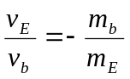 and 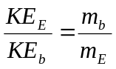

Find the order of magnitude of the ratio of the kinetic energies, based on data that you specify.

24. Two ice skaters are holding hands at the center of a frozen pond when an argument ensues. Skater A shoves skater B along a horizontal direction. Identify (a) the horizontal forces acting on A and (b) those acting on B. (c) Which force is greater, the force on A or the force on B? (d) Can conservation of momentum be used for the system of A and B? Defend your answer. (e) If A has a mass of 0.900 times that of B, and B begins to move away with a speed of 2.00 m/s, find the speed of A.

Section 6.3 Collisions
Section 6.4 Glancing Collisions

25. An archer shoots an arrow toward a 300-g target that is sliding in her direction at a speed of 2.50 m/s on a smooth, slippery surface. The 22.5-g arrow is shot with a speed of 35.0 m/s and passes through the target, which is stopped by the impact. What is the speed of the arrow after passing through the target?
26. A 75.0-kg ice skater moving at 10.0 m/s crashes into a stationary skater of equal mass. After the collision, the two skaters move as a unit at 5.00 m/s. Suppose the average force a skater can experience without breaking a bone is 4 500 N. If the impact time is 0.100 s, does a bone break?

27. A railroad car of mass 2.00 × 10⁴ kg moving at 3.00 m/s collides and couples with two coupled railroad cars, each of the same mass as the single car and moving in the same direction at 1.20 m/s. (a) What is the speed of the three coupled cars after the collision? (b) How much kinetic energy is lost in the collision?

28. A 7.0-g bullet is fired into a 1.5-kg ballistic pendulum. The bullet emerges from the block with a speed of 200 m/s, and the block rises to a maximum height of 12 cm. Find the initial speed of the bullet.

29. A 0.030-kg bullet is fired vertically at 200 m/s into a 0.15-kg baseball that is initially at rest. How high does the combined bullet and baseball rise after the collision, assuming the bullet embeds itself in the ball?

30. An 8.00-g bullet is fired into a 250-g block that is initially at rest at the edge of a table of height 1.00 m (Fig. P6.30). The bullet remains in the block, and after the impact the block lands 2.00 m from the bottom of the table. Determine the initial speed of the bullet.

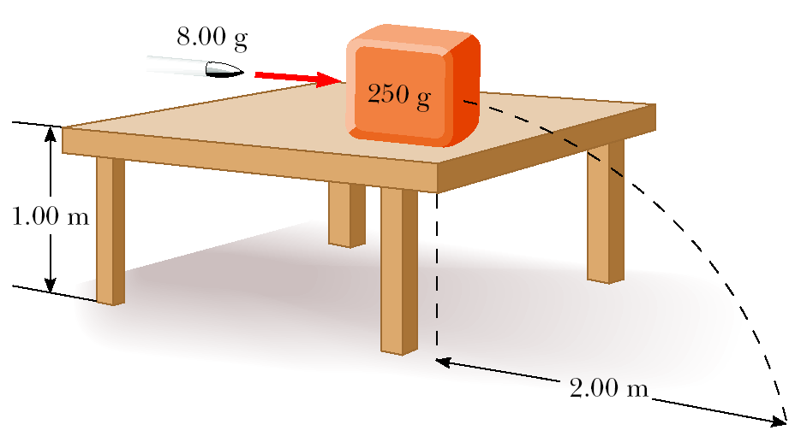
Figure P6.30

31. Gayle runs at a speed of 4.00 m/s and dives on a sled, initially at rest on the top of a frictionless, snow-covered hill. After she has descended a vertical distance of 5.00 m, her brother, who is initially at rest, hops on her back, and they continue down the hill together. What is their speed at the bottom of the hill if the total vertical drop is 15.0 m? Gayle’s mass is 50.0 kg, the sled has a mass of 5.00 kg, and her brother has a mass of 30.0 kg.

32. A 1 200-kg car traveling initially with a speed of 25.0 m/s in an easterly direction crashes into the rear end of a 9 000-kg truck moving in the same direction at 20.0 m/s (Fig. P6.32). The velocity of the car right after the collision is 18.0 m/s to the east. (a) What is the velocity of the truck right after the collision? (b) How much mechanical energy is lost in the collision? Account for this loss in energy.

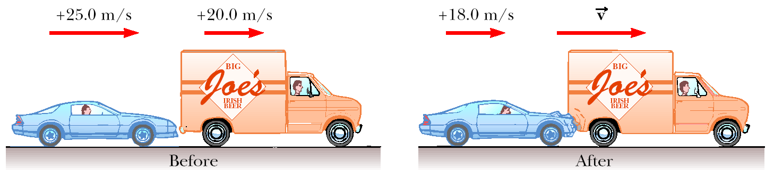
Figure P6.32

33. A 12.0-g bullet is fired horizontally into a 100-g wooden block that is initially at rest on a frictionless horizontal surface and connected to a spring having spring constant 150 N/m. The bullet becomes embedded in the block. If the bullet–block system compresses the spring by a maximum of 80.0 cm, what was the speed of the bullet at impact with the block?

34. (a) Three carts of masses 4.0 kg, 10 kg, and 3.0 kg move on a frictionless horizontal track with speeds of 5.0 m/s, 3.0 m/s, and 4.0 m/s, as shown in Figure P6.34. The carts stick together after colliding. Find the final velocity of the three carts. (b) Does your answer require that all carts collide and stick together at the same time?

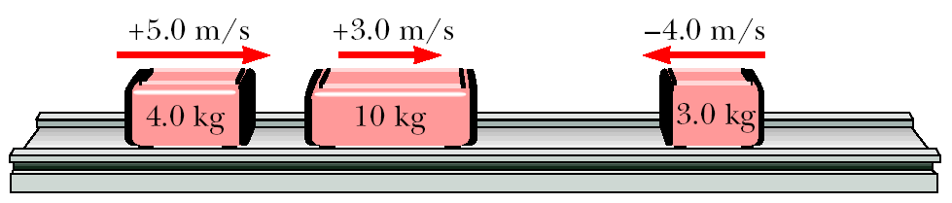
Figure P6.34

35. A 5.00-g object moving to the right at 20.0 cm/s makes an elastic head-on collision with a 10.0-g object that is initially at rest. Find (a) the velocity of each object after the collision and (b) the fraction of the initial kinetic energy transferred to the 10.0-g object.

36. A 10.0-g object moving to the right at 20.0 cm/s makes an elastic head-on collision with a 15.0-g object moving in the opposite direction at 30.0 cm/s. Find the velocity of each object after the collision.

37. A 25.0-g object moving to the right at 20.0 cm/s overtakes and collides elastically with a 10.0-g object moving in the same direction at 15.0 cm/s. Find the velocity of each object after the collision.

38. Four railroad cars, each of mass 2.50 × 10⁴ kg, are coupled together and coasting along horizontal tracks at speed v_{i} toward the south. A very strong but foolish movie actor riding on the second car uncouples the front car and gives it a big push, increasing its speed to 4.00 m/s south. The remaining three cars continue moving south, now at 2.00 m/s. (a) Find the initial speed of the cars. (b) How much work did the actor do?

39. When fired from a gun into a 1.00-kg block of wood held in a vise, a 7.00-g bullet penetrates the block to a depth of 8.00 cm. The block is then placed on a frictionless, horizontal surface, and a second 7.00-g bullet is fired from the gun into the block. To what depth does the bullet penetrate the block in this case?

40. A billiard ball rolling across a table at 1.50 m/s makes a head-on elastic collision with an identical ball. Find the speed of each ball after the collision (a) when the second ball is initially at rest, (b) when the second ball is moving toward the first at a speed of 1.00 m/s, and (c) when the second ball is moving away from the first at a speed of 1.00 m/s.

41. A 90-kg fullback moving east with a speed of 5.0 m/s is tackled by a 95-kg opponent running north at 3.0 m/s. If the collision is perfectly inelastic, calculate (a) the velocity of the players just after the tackle and (b) the kinetic energy lost as a result of the collision. Can you account for the missing energy?

42. An 8.00-kg object moving east at 15.0 m/s on a frictionless horizontal surface collides with a 10.0-kg object that is initially at rest. After the collision, the 8.00-kg object moves south at 4.00 m/s. (a) What is the velocity of the 10.0-kg object after the collision? (b) What percentage of the initial kinetic energy is lost in the collision?

43. A 2 000-kg car moving east at 10.0 m/s collides with a 3 000-kg car moving north. The cars stick together and move as a unit after the collision, at an angle of 40.0° north of east and a speed of 5.22 m/s. Find the speed of the 3 000-kg car before the collision.

44. Two automobiles of equal mass approach an intersection. One vehicle is traveling with velocity 13.0 m/s toward the east, and the other is traveling north with speed v_{2i}. Neither driver sees the other. The vehicles collide in the intersection and stick together, leaving parallel skid marks at an angle of 55.0° north of east. The speed limit for both roads is 35 mi/h, and the driver of the northward-moving vehicle claims he was within the limit when the collision occurred. Is he telling the truth?
45. A billiard ball moving at 5.00 m/s strikes a stationary ball of the same mass. After the collision, the first ball moves at 4.33 m/s at an angle of 30° with respect to the original line of motion. (a) Find the velocity (magnitude and direction) of the second ball after collision. (b) Was the collision inelastic or elastic?

Additional Problems
46. In research in cardiology and exercise physiology, it is often important to know the mass of blood pumped by a person’s heart in one stroke. This information can be obtained by means of a ballistocardiograph. The instrument works as follows: The subject lies on a horizontal pallet floating on a film of air. Friction on the pallet is negligible. Initially, the momentum of the system is zero. When the heart beats, it expels a mass m of blood into the aorta with speed v, and the body and platform move in the opposite direction with speed V. The speed of the blood can be determined independently (for example, by observing an ultrasound Doppler shift). Assume that the blood’s speed is 50.0 cm/s in one typical trial. The mass of the subject plus the pallet is 54.0 kg. The pallet moves 6.00 × 10^{–5} m in 0.160 s after one heartbeat. Calculate the mass of blood that leaves the heart. Assume that the mass of blood is negligible compared with the total mass of the person. This simplified example illustrates the principle of ballistocardiography, but in practice a more sophisticated model of heart function is used.

47. A 0.50-kg object is at rest at the origin of a coordinate system. A 3.0-N force in the +x-direction acts on the object for 1.50 s. (a) What is the velocity at the end of this interval? (b) At the end of the interval, a constant force of 4.0 N is applied in the –x-direction for 3.0 s. What is the velocity at the end of the 3.0 s?

48. Consider a frictionless track as shown in Figure P6.48. A block of mass m₁ = 5.00 kg is released from . It makes a head-on elastic collision at with a block of mass m₂ = 10.0 kg that is initially at rest. Calculate the maximum height to which m₁ rises after the collision.

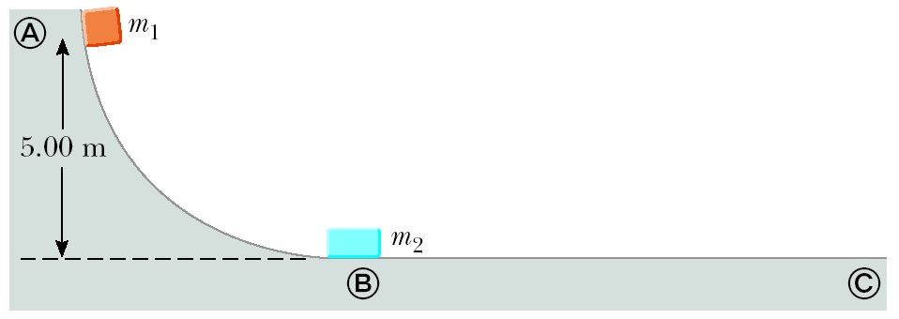
Figure P6.48

49. Most of us know intuitively that in a head-on collision between a large dump truck and a subcompact car, you are better off being in the truck than in the car. Why is this? Many people imagine that the collision force exerted on the car is much greater than that exerted on the truck. To substantiate this view, they point out that the car is crushed, whereas the truck is only dented. This idea of unequal forces, of course, is false; Newton’s third law tells us that both objects are acted upon by forces of the same magnitude. The truck suffers less damage because it is made of stronger metal. But what about the two drivers? Do they experience the same forces? To answer this question, suppose that each vehicle is initially moving at 8.00 m/s and that they undergo a perfectly inelastic headon collision. Each driver has mass 80.0 kg. Including the masses of the drivers, the total masses of the vehicles are 800 kg for the car and 4 000 kg for the truck. If the collision time is 0.120 s, what force does the seat belt exert on each driver?

50. A bullet of mass m and speed v passes completely through a pendulum bob of mass M as shown in Figure P6.50. The bullet emerges with a speed of v/2. The pendulum bob is suspended by a stiff rod of length and negligible mass. What is the minimum value of v such that the bob will barely swing through a complete vertical circle?

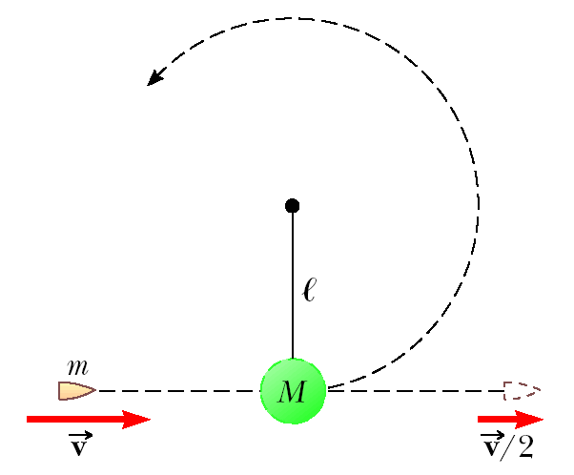
Figure P6.50

51. A 2.0-g particle moving at 8.0 m/s makes a perfectly elastic head-on collision with a resting 1.0-g object. (a) Find the speed of each particle after the collision. (b) Find the speed of each particle after the collision if the stationary particle has a mass of 10 g. (c) Find the final kinetic energy of the incident 2.0-g particle in the situations described in (a) and (b). In which case does the incident particle lose more kinetic energy?

52. A 0.400-kg green bead slides on a curved frictionless wire, starting from rest at point in Figure P6.52. At point , the bead collides elastically with a 0.600-kg blue ball at rest. Find the maximum height the blue ball rises as it moves up the wire.

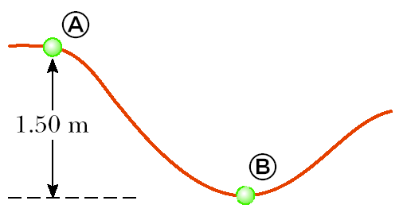
Figure P6.52

53. An 80-kg man standing erect steps off a 3.0-m-high diving platform and begins to fall from rest. The man again comes to rest 2.0 s after reaching the water. What average force did the water exert on him?

54. A 12.0-g bullet is fired horizontally into a 100-g wooden block initially at rest on a horizontal surface. After impact, the block slides 7.5 m before coming to rest. If the coefficient of kinetic friction between block and surface is 0.650, what was the speed of the bullet immediately before impact?

55. A 60.0-kg person running at an initial speed of 4.00 m/s jumps onto a 120-kg cart that is initially at rest (Figure P6.55). The person slides on the cart’s top surface and finally comes to rest relative to the cart. The coefficient of kinetic friction between the person and the cart is 0.400. Friction between the cart and ground can be neglected. (a) Find the final speed of the person and cart relative to the ground. (b) Find the frictional force acting on the person while he is sliding across the top surface of the cart. (c) How long does the frictional force act on the person? (d) Find the change in momentum of the person and the change in momentum of the cart. (e) Determine the displacement of the person relative to the ground while he is sliding on the cart. (f) Determine the displacement of the cart relative to the ground while the person is sliding. (g) Find the change in kinetic energy of the person. (h) Find the change in kinetic energy of the cart. (i) Explain why the answers to (g) and (h) differ. (What kind of collision is this, and what accounts for the loss of mechanical energy?)

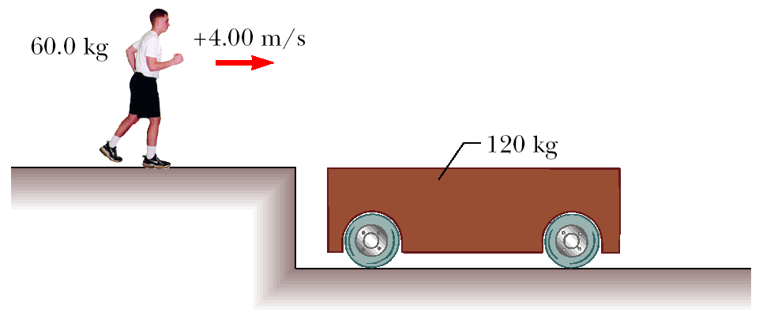
Figure P6.55

56. Two blocks of masses m₁ = 2.00 kg and m₂ = 4.00 kg are each released from rest at a height of 5.00 m on a frictionless track, as shown in Figure P6.56, and undergo an elastic head-on collision. (a) Determine the velocity of each block just before the collision. (b) Determine the velocity of each block immediately after the collision. (c) Determine the maximum heights to which m₁ and m₂ rise after the collision.

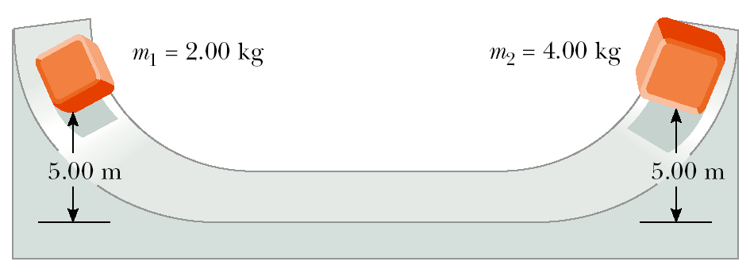
Figure P6.56

57. A 0.500-kg block is released from rest at the top of a frictionless track 2.50 m above the top of a table. It then collides elastically with a 1.00-kg object that is initially at rest on the table, as shown in Figure P6.57. (a) Determine the velocities of the two objects just after the collision. (b) How high up the track does the 0.500-kg object travel back after the collision? (c) How far away from the bottom of the table does the 1.00-kg object land, given that the table is 2.00 m high? (d) How far away from the bottom of the table does the 0.500-kg object eventually land?

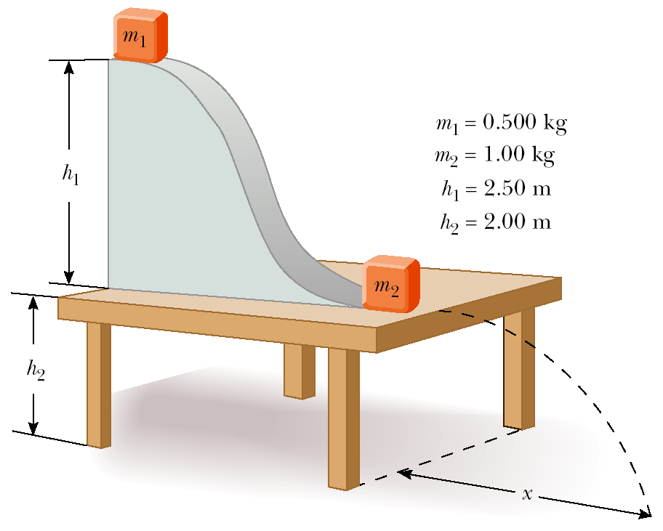
Figure P6.57

58. Tarzan, whose mass is 80.0 kg, swings from a 3.00-m vine that is horizontal when he starts. At the bottom of his arc, he picks up 60.0-kg Jane in a perfectly inelastic collision. What is the height of the highest tree limb they can reach on their upward swing?

59. A small block of mass m₁ = 0.500 kg is released from rest at the top of a curved wedge of mass m₂ = 3.00 kg, which sits on a frictionless horizontal surface as in Figure P6.59a. When the block leaves the wedge, its velocity is measured to be 4.00 m/s to the right, as in Figure P6.59b. (a) What is the velocity of the wedge after the block reaches the horizontal surface? (b) What is the height h of the wedge?

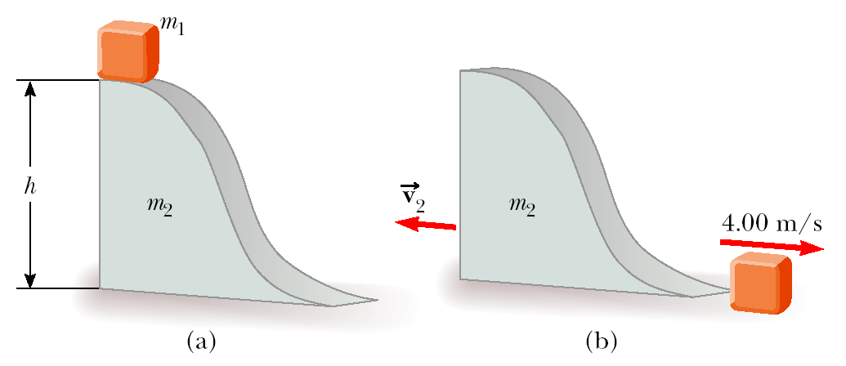
Figure P6.59

60. Two carts of equal mass m = 0.250 kg are placed on a frictionless track that has a light spring of force constant k = 50.0 N/m attached to one end of it, as in Figure P6.60. The red cart is given an initial velocity of = 3.00 m/s to the right, and the blue cart is initially at rest. If the carts collide elastically, find (a) the velocity of the carts just after the first collision and (b) the maximum compression of the spring.

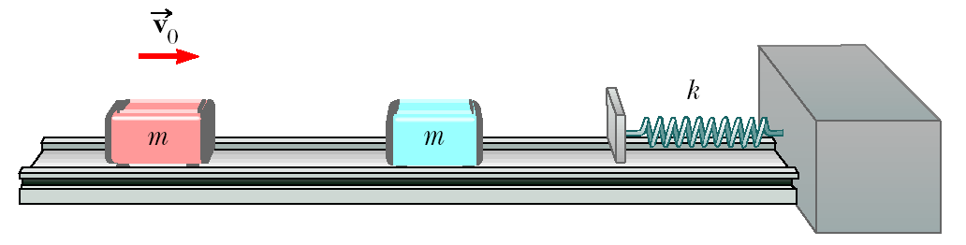
Figure P6.60

61. A cannon is rigidly attached to a carriage, which can move along horizontal rails, but is connected to a post by a large spring, initially unstretched and with force constant k = 2.00 × 10⁴ N/m, as in Figure P6.61. The cannon fires a 200-kg projectile at a velocity of 125 m/s directed 45.0° above the horizontal. (a) If the mass of the cannon and its carriage is 5 000 kg, find the recoil speed of the cannon. (b) Determine the maximum extension of the spring. (c) Find the maximum force the spring exerts on the carriage. (d) Consider the system consisting of the cannon, the carriage, and the shell. Is the momentum of this system conserved during the firing? Why or why not?

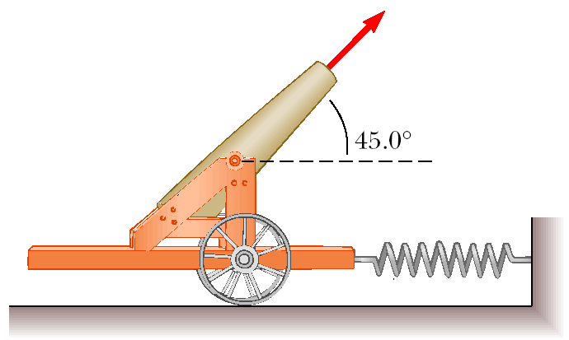
Figure P6.61

62. Two objects of masses m and 3m are moving toward each other along the x-axis with the same initial speed v₀. The object with mass m is traveling to the left, and the object with mass 3m is traveling to the right. They undergo an elastic glancing collision such that m is moving downward after the collision at right angles from its initial direction. (a) Find the final speeds of the two objects. (b) What is the angle θ at which the object with mass 3m is scattered?
63. A neutron in a reactor makes an elastic head-on collision with a carbon atom that is initially at rest. (The mass of the carbon nucleus is about 12 times that of the neutron.) (a) What fraction of the neutron’s kinetic energy is transferred to the carbon nucleus? (b) If the neutron’s initial kinetic energy is 1.6 × 10^{–13} J, find its final kinetic energy and the kinetic energy of the carbon nucleus after the collision.

64. A cue ball traveling at 4.00 m/s makes a glancing, elastic collision with a target ball of equal mass that is initially at rest. The cue ball is deflected so that it makes an angle of 30.0° with its original direction of travel. Find (a) the angle between the velocity vectors of the two balls after the collision and (b) the speed of each ball after the collision.

65. A block of mass m lying on a rough horizontal surface is given an initial velocity of 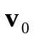. After traveling a distance d, it makes a head-on elastic collision with a block of mass 2m. How far does the second block move before coming to rest? (Assume that the coefficient of friction, μ_{k}, is the same for both blocks.)

66. The “force platform” is a tool that is used to analyze the performance of athletes by measuring the vertical force as a function of time that the athlete exerts on the ground in performing various activities. A simplified force vs. time graph for an athlete performing a standing high jump is shown in Figure P6.66. The athlete started the jump at t = 0.0 s. How high did this athlete jump?
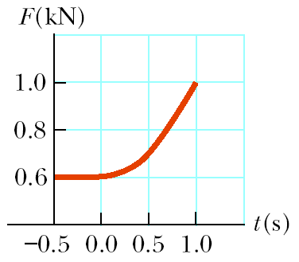
Figure P6.66

67. (a) A car traveling due east strikes a car traveling due north at an intersection, and the two move together as a unit. A property owner on the southeast corner of the intersection claims that his fence was torn down in the collision. Should he be awarded damages by the insurance company? Defend your answer. (b) Let the eastward-moving car have a mass of 1 300 kg and a speed of 30.0 km/h and the northward-moving car a mass of 1 100 kg and a speed of 20.0 km/h. Find the velocity after the collision. Are the results consistent with your answer to part (a)?

68. Two blocks collide on a frictionless surface. After the collision, the blocks stick together. Block A has a mass M and is initially moving to the right at speed v. Block B has a mass 2M and is initially at rest. System C is composed of both blocks. (a) Draw a free-body diagram for each block at an instant during the collision. (b) Rank the magnitudes of the horizontal forces in your diagram. Explain your reasoning. (c) Calculate the change in momentum of block A, block B, and system C. (d) Is kinetic energy conserved in this collision? Explain your answer. (This problem is courtesy of Edward F. Redish. For more such problems, visit http://www.physics.umd.edu/perg.)

69. A tennis ball of mass 57.0 g is held just above a basketball of mass 590 g. With their centers vertically aligned, both balls are released from rest at the same time, to fall through a distance of 1.20 m, as shown in Figure P6.69. (a) Find the magnitude of the downward velocity with which the basketball reaches the ground. (b) Assume that an elastic collision with the ground instantaneously reverses the velocity of the basketball while the tennis ball is still moving down. Next, the two balls meet in an elastic collision. (b) To what height does the tennis ball rebound?

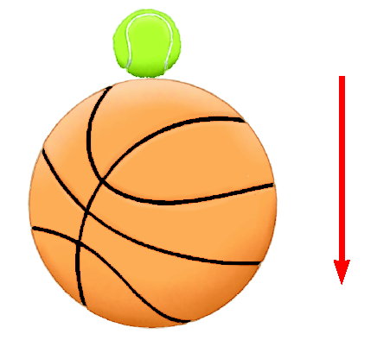
Figure P6.69

70. A 60-kg soccer player jumps vertically upwards and heads the 0.45-kg ball as it is descending vertically with a speed of 25 m/s. If the player was moving upward with a speed of 4.0 m/s just before impact, what will be the speed of the ball immediately after the collision if the ball rebounds vertically upwards and the collision is elastic? If the ball is in contact with the player’s head for 20 ms, what is the average acceleration of the ball? (Note that the force of gravity may be ignored during the brief collision time.)

71. Small ice cubes, each of mass 5.00 g, slide down a frictionless ski-jump track in a steady stream, as shown in Figure P6.71. Starting from rest, each cube moves down through a net vertical distance of 1.50 m and leaves the bottom end of the track at an angle of 40.0° above the horizontal. At the highest point of its subsequent trajectory, the cube strikes a vertical wall and rebounds with half the speed it had upon impact. If 10.0 cubes strike the wall per second, what average force is exerted on the wall?

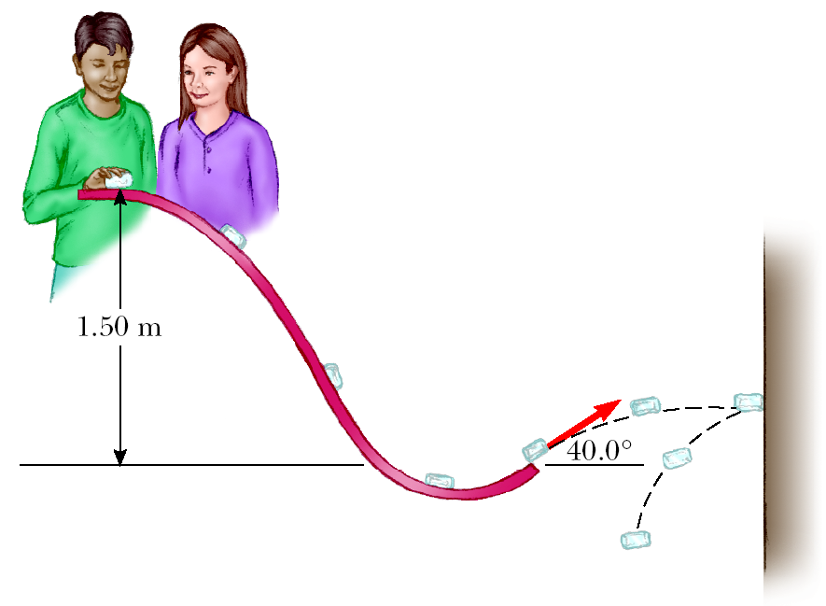
Figure P6.71

72. A 0.30-kg puck, initially at rest on a frictionless horizontal surface, is struck by a 0.20-kg puck that is initially moving along the x-axis with a velocity of 2.0 m/s. After the collision, the 0.20-kg puck has a speed of 1.0 m/s at an angle of θ = 53° to the positive x-axis. (a) Determine the velocity of the 0.30-kg puck after the collision. (b) Find the fraction of kinetic energy lost in the collision.

73. A cannon initially resting on a frictionless surface of mass m₁ = 800 kg (when unloaded) is loaded with a “shot” of mass m₂ = 10.0 kg. The cannon is aimed at mass m₃ = 7 990 kg, which is connected to a massless spring of force constant k = 4 500 N/m, as in Figure P6.73a. The cannon is then fired, and the shot inelastically collides with mass m₃ and sticks in it, as shown in Figure P6.73b. The combined system compresses the spring a maximum distance of d = 0.500 m, as in Figure P6.73c. (a) Determine the speed of m₂ just before it collides with m₃. (You may assume that m₂ travels in a straight line.) (b) Determine the recoil speed of the cannon. (c) The cannon recoils towards the right, and when it passes point A there is friction (with μ_{k} = 0.600) between the cannon and the ground. How far to the right of A does the cannon slide before coming to rest?

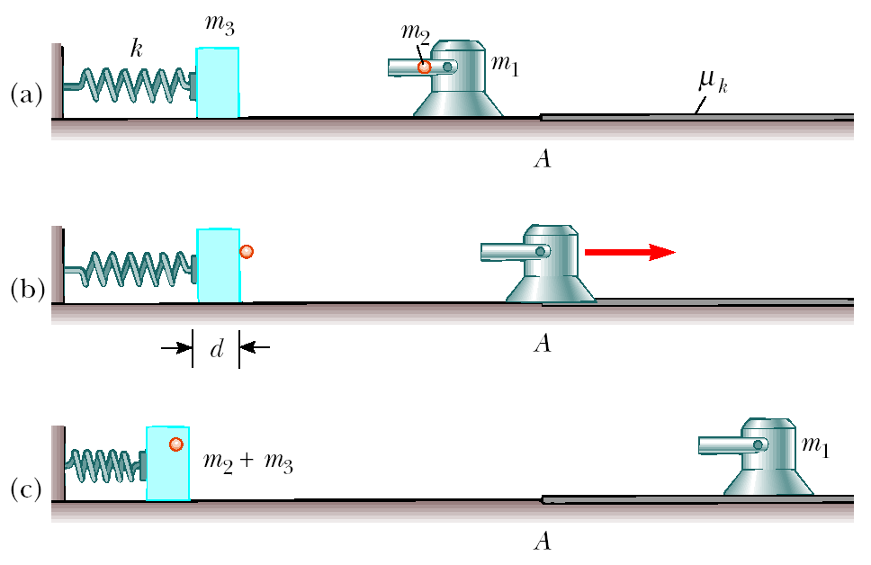
Figure P6.73

74. A flying squid (family Ommastrephidae) is able to “jump” off the surface of the sea by taking water into its body cavity and then ejecting the water vertically downward. A 0.85-kg squid is able to eject 0.30 kg of water with a speed of 20 m/s. (a) What will be the speed of the squid immediately after ejecting the water. (b) How high in the air will the squid rise?

© Copyright 2004 Thomson. All rights reserved.

