Chapter 8 Problems

1, 2, 3 = straightforward, intermediate, challenging
= full solution available in Student Solutions Manual/Study Guide
= co ached solution with hints available at www.cp7e.com
= biomedical application

Section 8.1 Torque

1. If the torque required to loosen a nut that is holding a flat tire in place on a car has a magnitude of 40.0 N ∙ m, what minimum force must be exerted by the mechanic at the end of a 30.0-cm lug wrench to accomplish the task?

2. A steel band exerts a horizontal force of 80.0 N on a tooth at point B in Figure P8.2. What is the torque on the root of the tooth about point A?

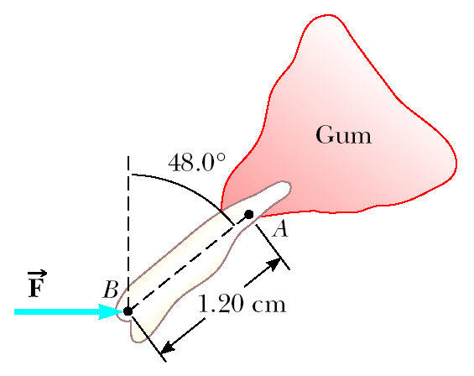
Figure P8.2

3. Calculate the net torque (magnitude and direction) on the beam in Figure P8.3 about (a) an axis through O perpendicular to the page and (b) an axis through C perpendicular to the page.

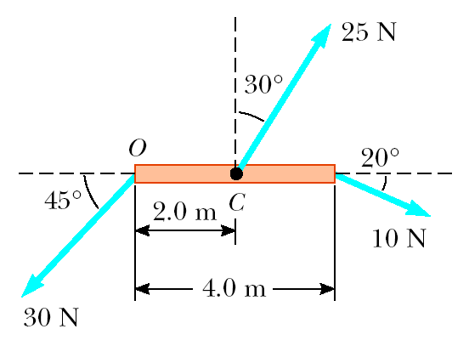
Figure P8.3

4. Write the necessary equations of equilibrium of the object shown in Figure P8.4. Take the origin of the torque equation about an axis perpendicular to the page through the point O.

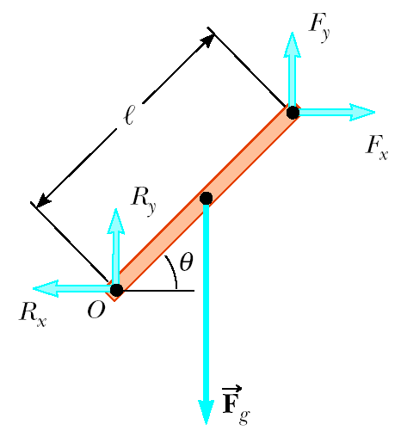
Figure P8.4

5. A simple pendulum consists of a small object of mass 3.0 kg hanging at the end of a 2.0-m-long light string that is connected to a pivot point. Calculate the magnitude of the torque (due to the force of gravity) about this pivot point when the string makes a 5.0° angle with the vertical.

6. A fishing pole is 2.00 m long and inclined to the horizontal at an angle of 20.0° (Fig. P8.6). What is the torque exerted by the fish about an axis perpendicular to the page and passing through the hand of the person holding the pole?

Figure P8.6

Section 8.2 Torque and the Two Conditions for Equilibrium
Section 8.3 The Center of Gravity
Section 8.4 Examples of Objects in Equilibrium
7. The arm in Figure P8.7 weighs 41.5 N. The force of gravity acting on the arm acts through point A. Determine the magnitudes of the tension force ${\vec{F}}_{t}$ in the deltoid muscle and the force ${\vec{F}}_{s}$ exerted by the shoulder on the humerus (upper-arm bone) to hold the arm in the position shown.

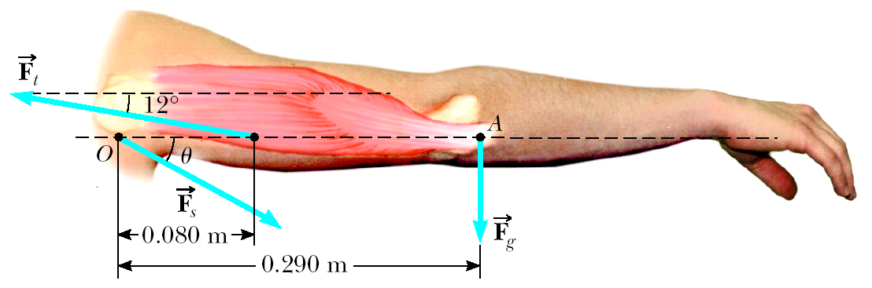
Figure P8.7

8. A water molecule consists of an oxygen atom with two hydrogen atoms bound to it as shown in Figure P8.8. The bonds are 0.100 nm in length, and the angle between the two bonds is 106°. Use the coordinate axes shown, and determine the location of the center of gravity of the molecule. Take the mass of an oxygen atom to be 16 times the mass of a hydrogen atom.

Figure P8.8
9. A cook holds a 2.00-kg carton of milk at arm’s length (Fig. P8.9). What force ${\vec{F}}_{B}$ must be exerted by the biceps muscle? (Ignore the weight of the forearm.)

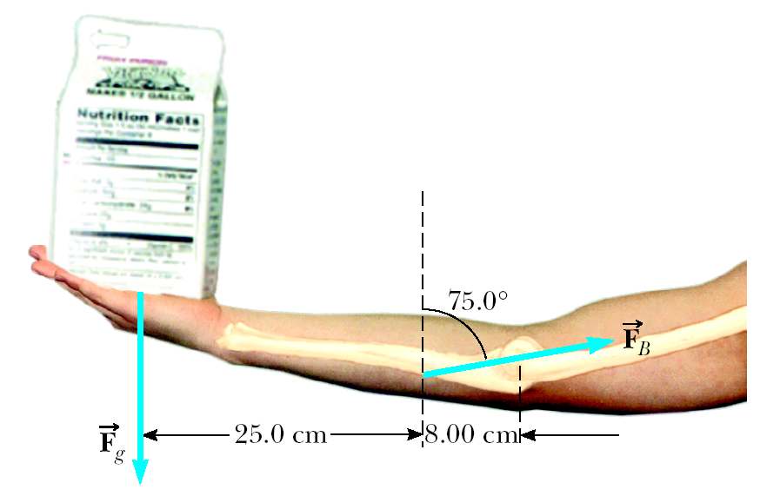
Figure P8.9

10. A meterstick is found to balance at the 49.7-cm mark when placed on a fulcrum. When a 50.0-gram mass is attached at the 10.0-cm mark, the fulcrum must be moved to the 39.2-cm mark for balance. What is the mass of the meter stick?

11. Find the x- and y-coordinates of the center of gravity of a 4.00-ft by 8.00-ft uniform sheet of plywood with the upper right quadrant removed as shown in Figure P8.11.

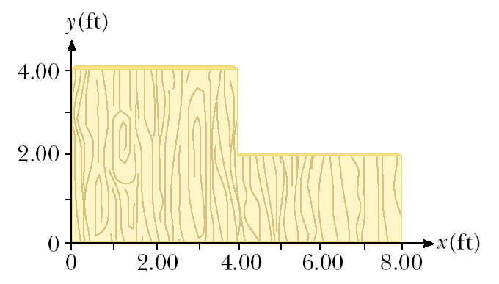
Figure P8.11

12. Consider the following mass distribution, where x- and y-coordinates are given in meters: 5.0 kg at (0.0, 0.0) m, 3.0 kg at (0.0, 4.0) m, and 4.0 kg at (3.0, 0.0) m. Where should a fourth object of 8.0 kg be placed so that the center of gravity of the four-object arrangement will be at (0.0, 0.0) m?
13. Many of the elements in horizontal-bar exercises can be modeled by representing the gymnast by four segments consisting of arms, torso (including the head), thighs, and lower legs, as shown in Figure P8.13a. Inertial parameters for a particular gymnast are as follows:

Segment | Mass (kg) | Length (m) | r_{cg} (m) | I (kg-m²)
Arms | 6.87 | 0.548 | 0.239 | 0.205
Torso | 33.57 | 0.601 | 0.337 | 1.610
Thighs | 14.07 | 0.374 | 0.151 | 0.173
Legs | 7.54 | — | 0.227 | 0.164

Note that in Figure P8.13a r_{cg} is the distance to the center of gravity measured from the joint closest to the bar and the masses for the arms, thighs, and legs include both appendages. I is the moment of inertia of each segment about its center of gravity. Determine the distance from the bar to the center of gravity of the gymnast for the two positions shown in Figures P8.13b and P8.13c.

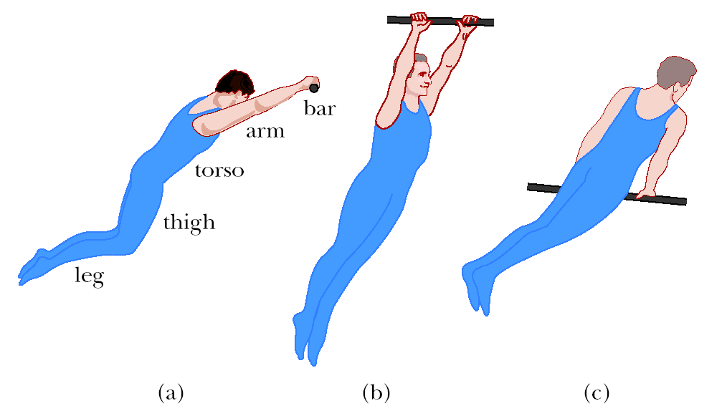
Figure P8.13
14. Using the data given in Problem 13 and the coordinate system shown in Figure P8.14b, calculate the position of the center of gravity of the gymnast shown in Figure P8.14a. Pay close attention to the definition of r_{cg} in the table.

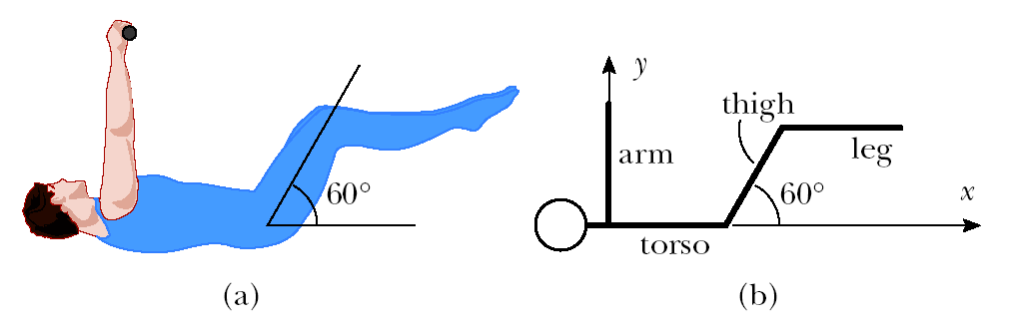
Figure P8.14
15. A person bending forward to lift a load “with his back” (Fig. P8.15a) rather than “with his knees” can be injured by large forces exerted on the muscles and vertebrae. The spine pivots mainly at the fifth lumbar vertebra, with the principal supporting force provided by the erector spinalis muscle in the back. To see the magnitude of the forces involved, and to understand why back problems are common among humans, consider the model shown in Fig. P8.15b of a person bending forward to lift a 200-N object. The spine and upper body are represented as a uniform horizontal rod of weight 350 N, pivoted at the base of the spine. The erector spinalis muscle, attached at a point two-thirds of the way up the spine, maintains the position of the back. The angle between the spine and this muscle is 12.0°. Find the tension in the back muscle and the compressional force in the spine.

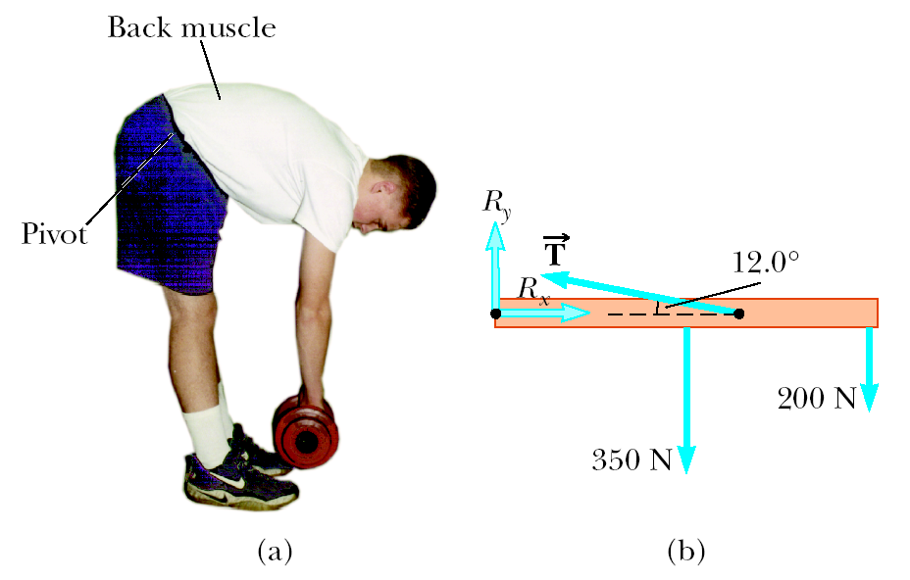
Figure P8.15
16. When a person stands on tiptoe (a strenuous position), the position of the foot is as shown in Figure P8.16a. The total gravitational force on the body, ${\vec{F}}_{g}$, is supported by the force $\vec{n}$ exerted by the floor on the toes of one foot. A mechanical model of the situation is shown in Figure P8.16b, where $\vec{T}$ is the force exerted by the Achilles tendon on the foot and $\vec{R}$ is the force exerted by the tibia on the foot. Find the values of T, R, and θ when F_{g} = 700 N.

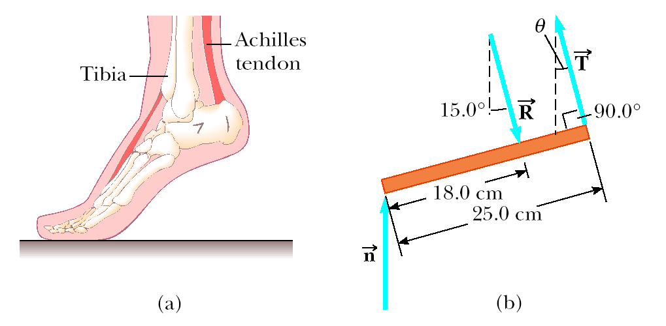
Figure P8.16

17. A 500-N uniform rectangular sign 4.00 m wide and 3.00 m high is suspended from a horizontal, 6.00-m-long, uniform, 100-N rod as indicated in Figure P8.17. The left end of the rod is supported by a hinge, and the right end is supported by a thin cable making a 30.0° angle with the vertical. (a) Find the tension T in the cable. (b) Find the horizontal and vertical components of force exerted on the left end of the rod by the hinge.

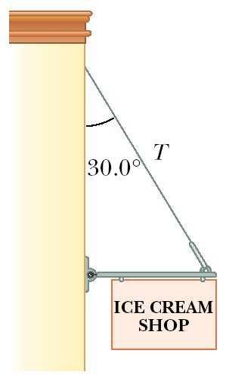
Figure P8.17

18. A window washer is standing on a scaffold supported by a vertical rope at each end. The scaffold weighs 200 N and is 3.00 m long. What is the tension in each rope when the 700-N worker stands 1.00 m from one end?
19. The chewing muscle, the masseter, is one of the strongest in the human body. It is attached to the mandible (lower jawbone) as shown in Figure P8.19a. The jawbone is pivoted about a socket just in front of the auditory canal. The forces acting on the jawbone are equivalent to those acting on the curved bar in Figure P8.19b: ${\vec{F}}_{c}$ is the force exerted by the food being chewed against the jawbone, $\vec{T}$ is the force of tension in the masseter, and $\vec{R}$ is the force exerted by the socket on the mandible. Find $\vec{T}$ and $\vec{R}$ for a person who bites down on a piece of steak with a force of 50.0 N.

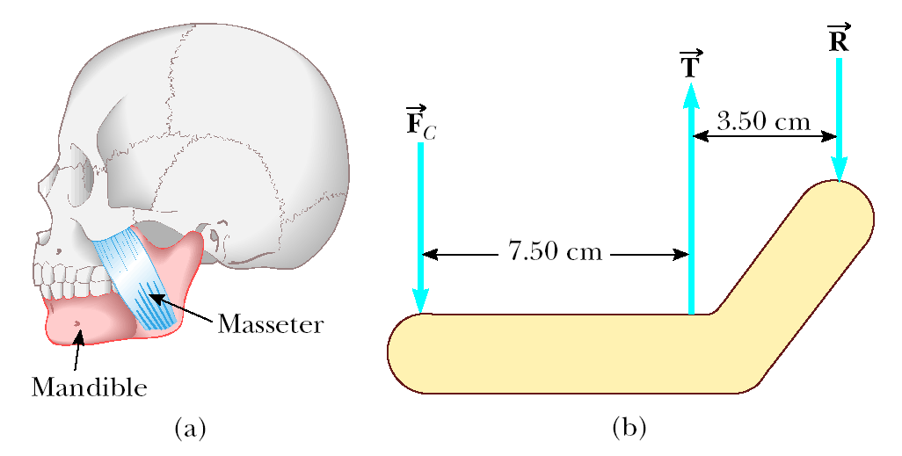
Figure P8.19

20. A hungry 700-N bear walks out on a beam in an attempt to retrieve some “goodies” hanging at the end (Fig. P8.20). The beam is uniform, weighs 200 N, and is 6.00 m long; the goodies weigh 80.0 N. (a) Draw a free-body diagram of the beam. (b) When the bear is at x = 1.00 m, find the tension in the wire and the components of the reaction force at the hinge. (c) If the wire can withstand a maximum tension of 900 N, what is the maximum distance the bear can walk before the wire breaks?
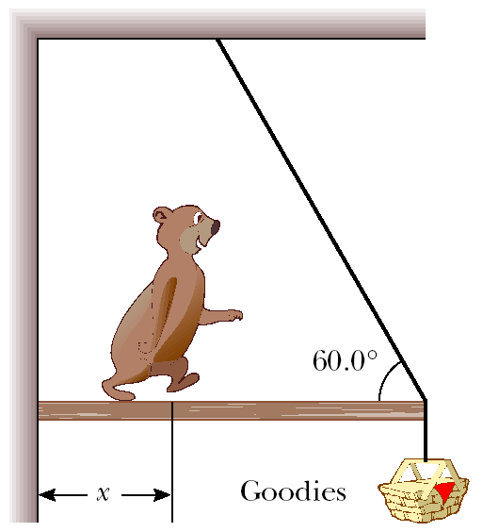
Figure P8.20

21. A uniform semicircular sign 1.00 m in diameter and of weight w is supported by two wires as shown in Figure P8.21. What is the tension in each of the wires supporting the sign?

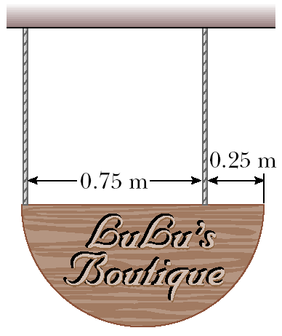
Figure P8.21

22. A 20.0-kg floodlight in a park is supported at the end of a horizontal beam of negligible mass that is hinged to a pole, as shown in Figure P8.22. A cable at an angle of 30.0° with the beam helps to support the light. Find (a) the tension in the cable and (b) the horizontal and vertical forces exerted on the beam by the pole.

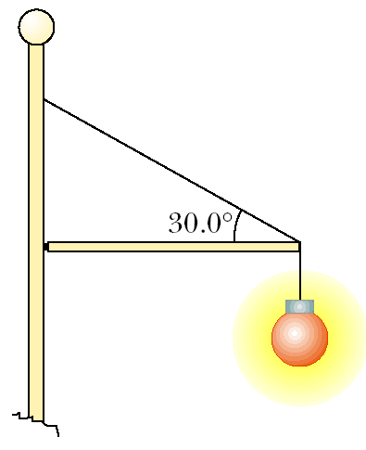
Figure P8.22

23. A uniform plank of length 2.00 m and mass 30.0 kg is supported by three ropes, as indicated by the blue vectors in Figure P8.23. Find the tension in each rope when a 700-N person is 0.500 m from the left end.

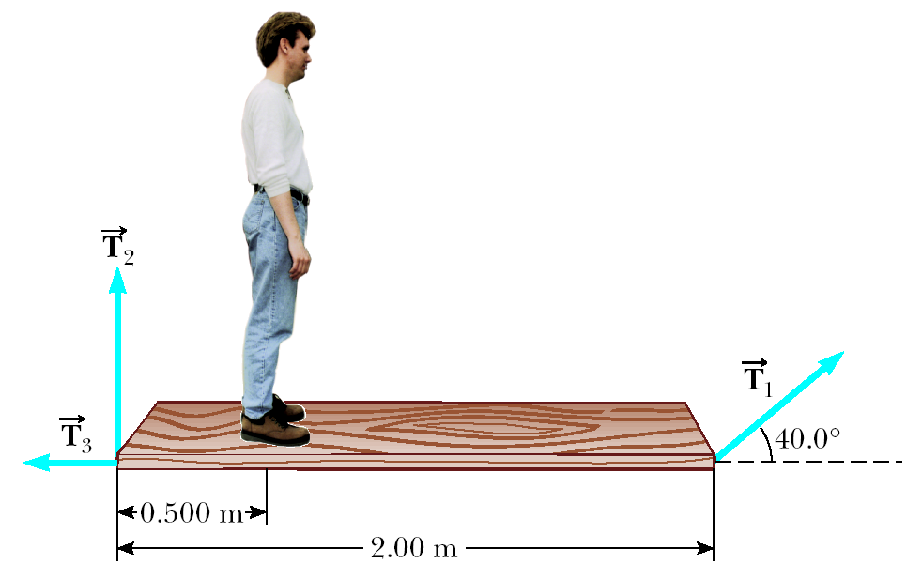
Figure P8.23

24. A 15.0-m, 500-N uniform ladder rests against a frictionless wall, making an angle of 60.0° with the horizontal. (a) Find the horizontal and vertical forces exerted on the base of the ladder by the Earth when an 800-N firefighter is 4.00 m from the bottom. (b) If the ladder is just on the verge of slipping when the firefighter is 9.00 m up, what is the coefficient of static friction between ladder and ground?

25. An 8.00-m, 200-N uniform ladder rests against a smooth wall. The coefficient of static friction between the ladder and the ground is 0.600, and the ladder makes a 50.0° angle with the ground. How far up the ladder can an 800-N person climb before the ladder begins to slip?

26. A 1 200-N uniform boom is supported by a cable perpendicular to the boom as in Figure P8.26. The boom is hinged at the bottom, and a 2 000-N weight hangs from its top. Find the tension in the supporting cable and the components of the reaction force exerted on the boom by the hinge.

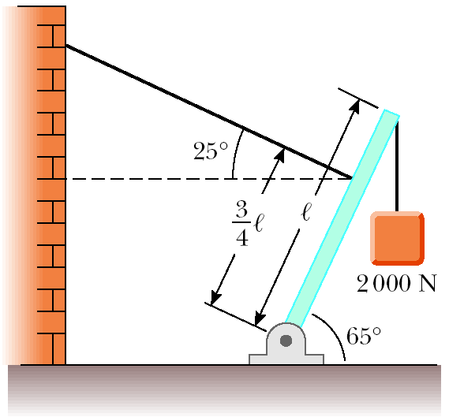
Figure P8.26
27. The large quadriceps muscle in the upper leg terminates at its lower end in a tendon attached to the upper end of the tibia (Fig. P8.27a). The forces on the lower leg when the leg is extended are modeled as in Figure P8.27b, where $\vec{T}$ is the force of tension in the tendon, $\vec{w}$ is the force of gravity acting on the lower leg, and $\vec{F}$ is the force of gravity acting on the foot. Find $\vec{T}$ when the tendon is at an angle of 25.0° with the tibia, assuming that w = 30.0 N, F = 12.5 N, and the leg is extended at an angle θ of 40.0° with the vertical. Assume that the center of gravity of the lower leg is at its center and that the tendon attaches to the lower leg at a point one-fifth of the way down the leg.

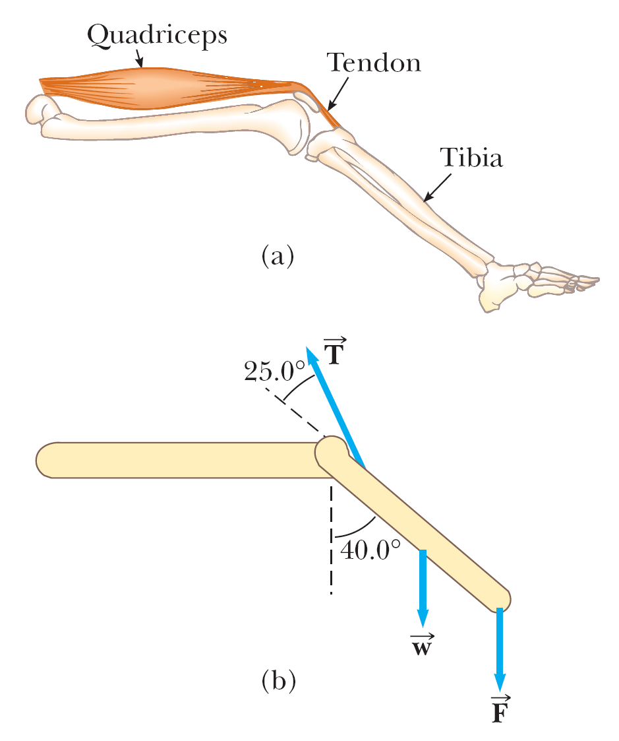
Figure P8.27

28. One end of a uniform 4.0-m-long rod of weight w is supported by a cable. The other end rests against a wall, where it is held by friction. (See Fig. P8.28.) The coefficient of static friction between the wall and the rod is μ_{s} = 0.50. Determine the minimum distance x from point A at which an additional weight w (the same as the weight of the rod) can be hung without causing the rod to slip at point A.

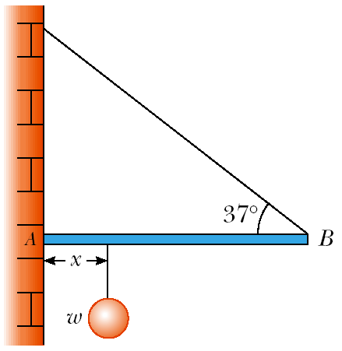
Figure P8.28

Section 8.5 Relationship Between Torque and Angular Acceleration

29. Four objects are held in position at the corners of a rectangle by light rods as shown in Figure P8.29. Find the moment of inertia of the system about (a) the x-axis, (b) the y-axis, and (c) an axis through O and perpendicular to the page.

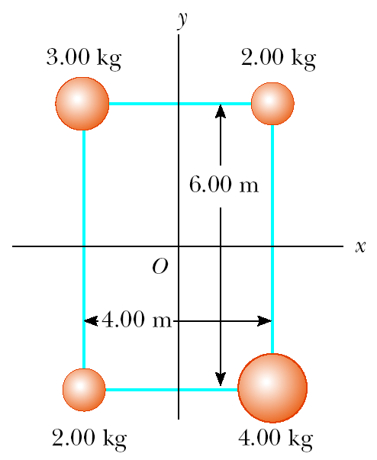
Figure P8.29 (Problems 29 and 30)

30. If the system shown in Figure P8.29 is set in rotation about each of the axes mentioned in Problem 29, find the torque that will produce an angular acceleration of 1.50 rad/s² in each case.

31. A model airplane with mass 0.750 kg is tethered by a wire so that it flies in a circle 30.0 m in radius. The airplane engine provides a net thrust of 0.800 N perpendicular to the tethering wire. (a) Find the torque the net thrust produces about the center of the circle. (b) Find the angular acceleration of the airplane when it is in level flight. (c) Find the linear acceleration of the airplane tangent to its flight path.

32. A potter’s wheel having a radius of 0.50 m and a moment of inertia of 12 kg ∙ m² is rotating freely at 50 rev/min. The potter can stop the wheel in 6.0 s by pressing a wet rag against the rim and exerting a radially inward force of 70 N. Find the effective coefficient of kinetic friction between the wheel and the wet rag.

33. A cylindrical fishing reel has a moment of inertia I = 6.8 × 10^{–4} kg ∙ m² and a radius of 4.0 cm. A friction clutch in the reel exerts a restraining torque of 1.3 N ∙ m if a fish pulls on the line. The fisherman gets a bite, and the reel begins to spin with an angular acceleration of 66 rad/s². (a) What is the force exerted by the fish on the line? (b) How much line unwinds in 0.50 s?

34. A bicycle wheel has a diameter of 64.0 cm and a mass of 1.80 kg. Assume that the wheel is a hoop with all the mass concentrated on the outside radius. The bicycle is placed on a stationary stand, and a resistive force of 120 N is applied tangent to the rim of the tire. (a) What force must be applied by a chain passing over a 9.00-cm-diameter sprocket in order to give the wheel an acceleration of 4.50 rad/s²? (b) What force is required if you shift to a 5.60-cm-diameter sprocket?

35. A 150-kg merry-go-round in the shape of a uniform, solid, horizontal disk of radius 1.50 m is set in motion by wrapping a rope about the rim of the disk and pulling on the rope. What constant force must be exerted on the rope to bring the merry-go-round from rest to an angular speed of 0.500 rev/s in 2.00 s?

36. A 5.00-kg cylindrical reel with a radius of 0.600 m and a frictionless axle starts from rest and speeds up uniformly as a 3.00-kg bucket falls into a well, making a light rope unwind from the reel (Fig. P8.36). The bucket starts from rest and falls for 4.00 s. (a) What is the linear acceleration of the falling bucket? (b) How far does it drop? (c) What is the angular acceleration of the reel?

37. An airliner lands with a speed of 50.0 m/s. Each wheel of the plane has a radius of 1.25 m and a moment of inertia of 110 kg ∙ m². At touchdown, the wheels begin to spin under the action of friction. Each wheel supports a weight of 1.40 × 10⁴ N, and the wheels attain their angular speed in 0.480 s while rolling without slipping. What is the coefficient of kinetic friction between the wheels and the runway? Assume that the speed of the plane is constant.

Section 8.6 Rotational Kinetic Energy

38. A constant torque of 25.0 N ∙ m is applied to a grindstone whose moment of inertia is 0.130 kg ∙ m². Using energy principles and neglecting friction, find the angular speed after the grindstone has made 15.0 revolutions. (Hint: The angular equivalent of W_{net} = FΔx = 1/2 mv_{f}² – 1/2 mv_{i}² is W_{net} = τΔθ = 1/2 Iω_{f}² – 1/2 Iω_{i}². You should convince yourself that this relationship is correct.)
39. A 10.0-kg cylinder rolls without slipping on a rough surface. At an instant when its center of gravity has a speed of 10.0 m/s, determine (a) the translational kinetic energy of its center of gravity, (b) the rotational kinetic energy about its center of gravity, and (c) its total kinetic energy.

40. Use conservation of energy to determine the angular speed of the spool shown in Figure P8.36 after the 3.00-kg bucket has fallen 4.00 m, starting from rest. The light string attached to the bucket is wrapped around the spool and does not slip as it unwinds.
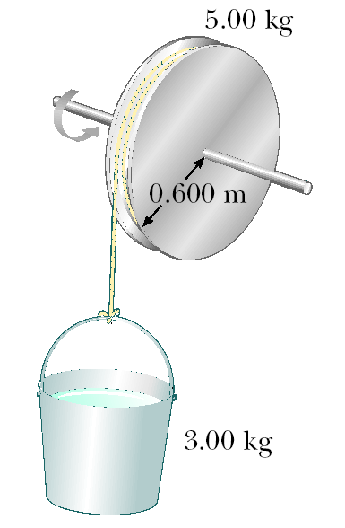
Figure P8.36 (Problems 36 and 40)

41. A horizontal 800-N merry-go-round of radius 1.50 m is started from rest by a constant horizontal force of 50.0 N applied tangentially to the merry-go-round. Find the kinetic energy of the merry-go-round after 3.00 s. (Assume it is a solid cylinder.)

42. A car is designed to get its energy from a rotating flywheel with a radius of 2.00 m and a mass of 500 kg. Before a trip, the flywheel is attached to an electric motor, which brings the flywheel’s rotational speed up to 5 000 rev/min. (a) Find the kinetic energy stored in the flywheel. (b) If the flywheel is to supply energy to the car as a 10.0-hp motor would, find the length of time the car could run before the flywheel would have to be brought back up to speed.

43. The top in Figure P8.43 has a moment of inertia of 4.00 × 10^{–4} kg ∙ m² and is initially at rest. It is free to rotate about a stationary axis AA’. A string wrapped around a peg along the axis of the top is pulled in such a manner as to maintain a constant tension of 5.57 N in the string. If the string does not slip while wound around the peg, what is the angular speed of the top after 80.0 cm of string has been pulled off the peg? [Hint: Consider the work that is done.]
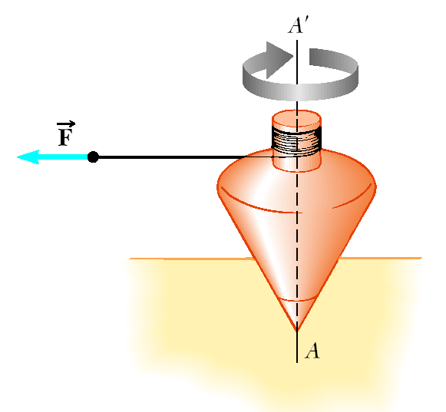
Figure P8.43

44. A 240-N sphere 0.20 m in radius rolls without slipping 6.0 m down a ramp that is inclined at 37° with the horizontal. What is the angular speed of the sphere at the bottom of the slope if it starts from rest?

Section 8.7 Angular Momentum

45. A light rigid rod 1.00 m in length rotates about an axis perpendicular to its length and through its center, as shown in Figure P8.45. Two particles of masses 4.00 kg and 3.00 kg are connected to the ends of the rod. What is the angular momentum of the system if the speed of each particle is 5.00 m/s? (Neglect the rod’s mass.)

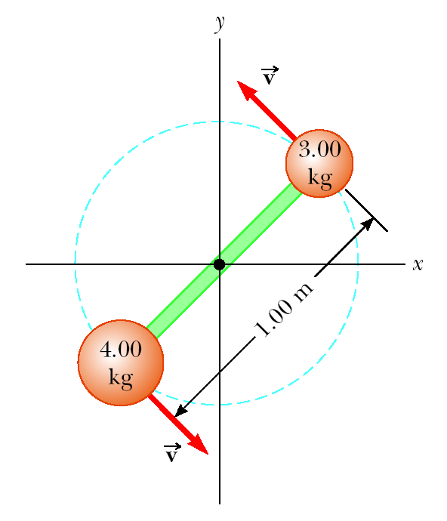
Figure P8.45

46. Halley’s comet moves about the Sun in an elliptical orbit, with its closest approach to the Sun being 0.59 A.U. and its greatest distance being 35 A.U. (1 A.U. is the Earth–Sun distance). If the comet’s speed at closest approach is 54 km/s, what is its speed when it is farthest from the Sun? You may neglect any change in the comet’s mass and assume that its angular momentum about the Sun is conserved.

47. The system of small objects shown in Figure P8.47 is rotating at an angular speed of 2.0 rev/s. The objects are connected by light, flexible spokes that can be lengthened or shortened. What is the new angular speed if the spokes are shortened to 0.50 m? (An effect similar to that illustrated in this problem occurred in the early stages of the formation of our galaxy. As the massive cloud of dust and gas that was the source of the stars and planets contracted, an initially small angular speed increased with time.)

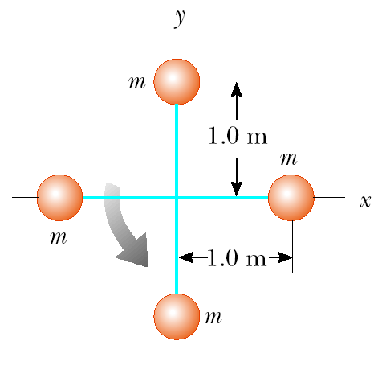
Figure P8.47

48. A playground merry-go-round of radius 2.00 m has a moment of inertia I = 275 kg ∙ m² and is rotating about a frictionless vertical axle. As a child of mass 25.0 kg stands at a distance of 1.00 m from the axle, the system (merry-go-round and child) rotates at the rate of 14.0 rev/min. The child then proceeds to walk toward the edge of the merry-go-round. What is the angular speed of the system when the child reaches the edge?

49. A solid, horizontal cylinder of mass 10.0 kg and radius 1.00 m rotates with an angular speed of 7.00 rad/s about a fixed vertical axis through its center. A 0.250-kg piece of putty is dropped vertically onto the cylinder at a point 0.900 m from the center of rotation and sticks to the cylinder. Determine the final angular speed of the system.

50. A student sits on a rotating stool holding two 3.0-kg objects. When his arms are extended horizontally, the objects are 1.0 m from the axis of rotation and he rotates with an angular speed of 0.75 rad/s. The moment of inertia of the student plus stool is 3.0 kg ∙ m² and is assumed to be constant. The student then pulls in the objects horizontally to 0.30 m from the rotation axis. (a) Find the new angular speed of the student. (b) Find the kinetic energy of the student before and after the objects are pulled in.

51. The puck in Figure P8.51 has a mass of 0.120 kg. Its original distance from the center of rotation is 40.0 cm, and it moves with a speed of 80.0 cm/s. The string is pulled downward 15.0 cm through the hole in the frictionless table. Determine the work done on the puck. [Hint: Consider the change in kinetic energy of the puck.]

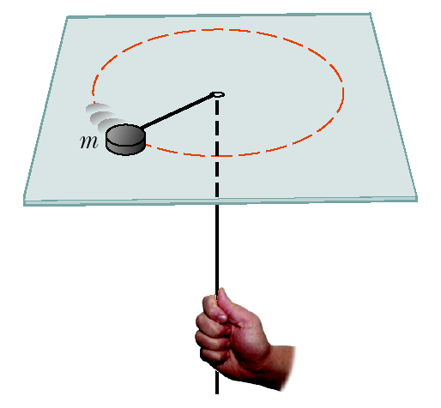
Figure P8.51

52. A merry-go-round rotates at the rate of 0.20 rev/s with an 80-kg man standing at a point 2.0 m from the axis of rotation. (a) What is the new angular speed when the man walks to a point 1.0 m from the center? Assume that the merry-go-round is a solid 25-kg cylinder of radius 2.0 m. (b) Calculate the change in kinetic energy due to the man’s movement. How do you account for this change in kinetic energy?

53. A 60.0-kg woman stands at the rim of a horizontal turntable having a moment of inertia of 500 kg ∙ m² and a radius of 2.00 m. The turntable is initially at rest and is free to rotate about a frictionless, vertical axle through its center. The woman then starts walking around the rim clockwise (as viewed from above the system) at a constant speed of 1.50 m/s relative to the Earth. (a) In what direction and with what angular speed does the turntable rotate? (b) How much work does the woman do to set herself and the turntable into motion?

54. A space station shaped like a giant wheel has a radius of 100 m and a moment of inertia of 5.00 × 10⁸ kg ∙ m². A crew of 150 lives on the rim, and the station is rotating so that the crew experiences an apparent acceleration of 1g (Fig. P8.54). When 100 people move to the center of the station for a union meeting, the angular speed changes. What apparent acceleration is experienced by the managers remaining at the rim? Assume the average mass of a crew member is 65.0 kg.

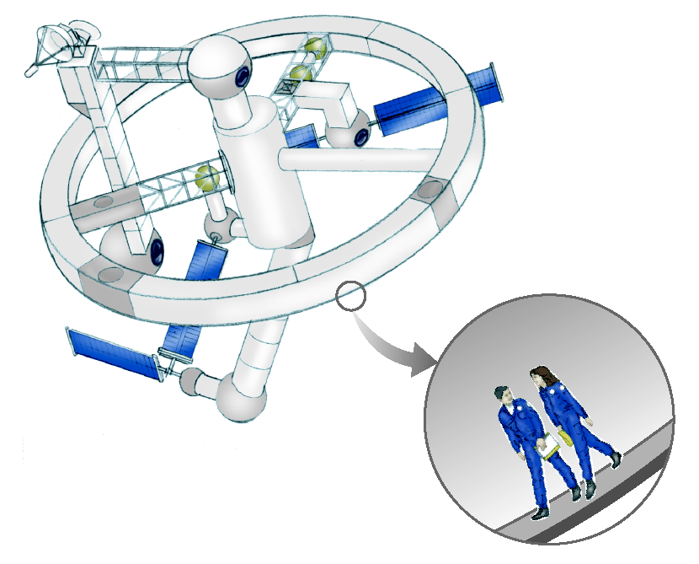
Figure P8.54

Additional Problems

55. A cylinder with moment of inertia I₁ rotates with angular velocity ω₀ about a frictionless vertical axle. A second cylinder, with moment of inertia I₂, initially not rotating, drops onto the first cylinder (Fig. P8.55). Since the surfaces are rough, the two cylinders eventually reach the same angular speed ω. (a) Calculate ω. (b) Show that kinetic energy is lost in this situation, and calculate the ratio of the final to the initial kinetic energy.

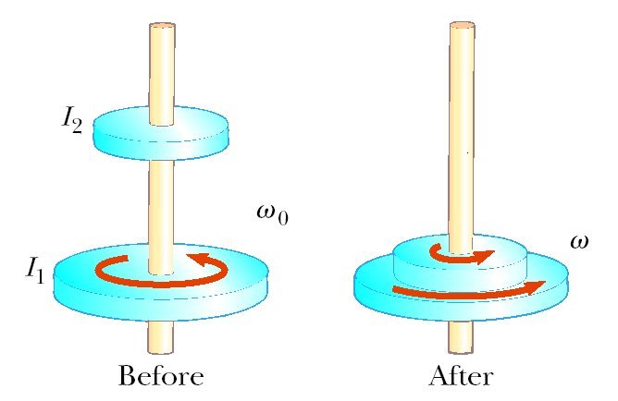
Figure P8.55

56. A new General Electric stove has a mass of 68.0 kg and the dimensions shown in Figure P8.56. The stove comes with a warning that it can tip forward if a person stands or sits on the oven door when it is open. What can you conclude about the weight of such a person? Could it be a child? List the assumptions you make in solving this problem. (The stove is supplied with a wall bracket to prevent the accident.)

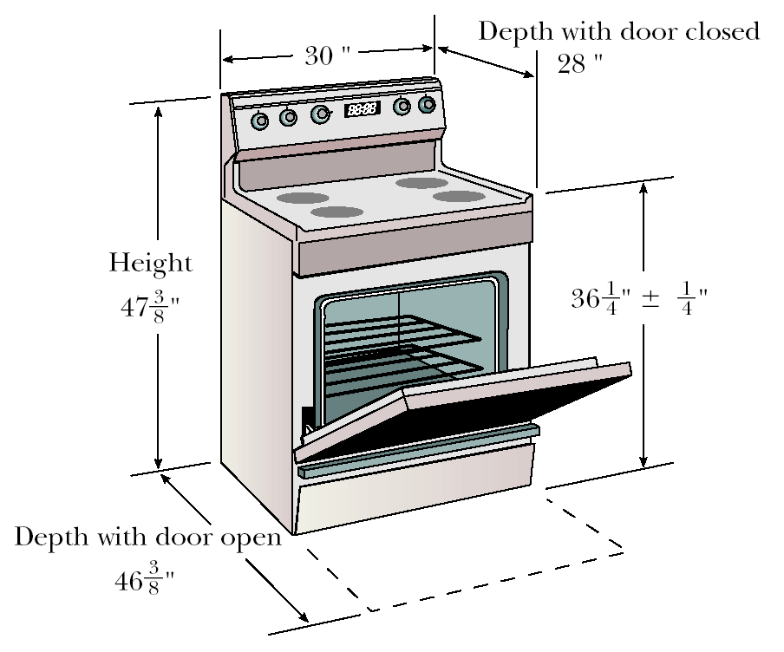
Figure P8.56

57. A 40.0-kg child stands at one end of a 70.0-kg boat that is 4.00 m long (Fig. P8.57). The boat is initially 3.00 m from the pier. The child notices a turtle on a rock beyond the far end of the boat and proceeds to walk to that end to catch the turtle. (a) Neglecting friction between the boat and water, describe the motion of the system (child plus boat). (b) Where will the child be relative to the pier when he reaches the far end of the boat? (c) Will he catch the turtle? (Assume that he can reach out 1.00 m from the end of the boat.)

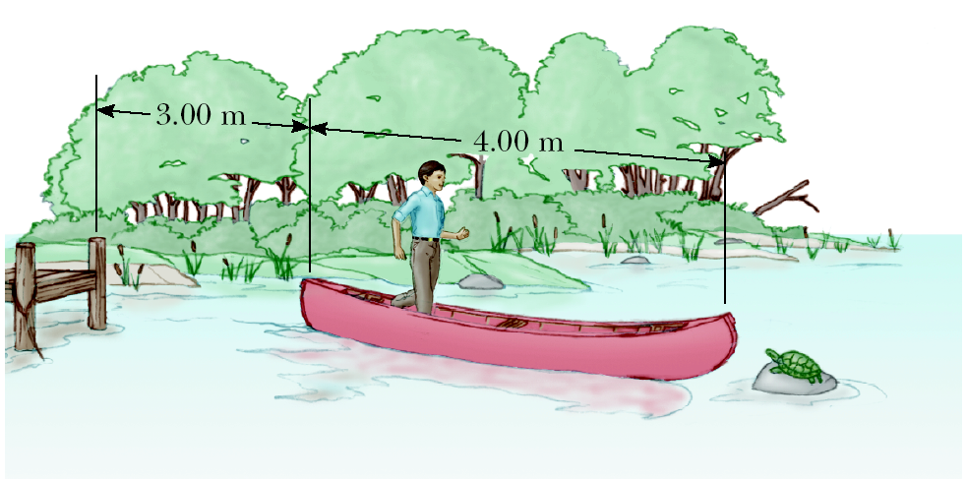
Figure P8.57

58. Figure P8.58 shows a clawhammer as it is being used to pull a nail out of a horizontal board. If a force of magnitude 150 N is exerted horizontally as shown, find (a) the force exerted by the hammer claws on the nail and (b) the force exerted by the surface at the point of contact with the hammer head. Assume that the force the hammer exerts on the nail is parallel to the nail.

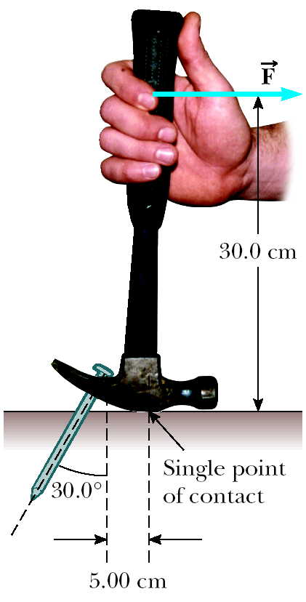
Figure P8.58

59. The pulley in Figure P8.59 has a moment of inertia of 5.0 kg ∙ m² and a radius of 0.50 m. The cord supporting the masses m₁ and m₂ does not slip, and the axle is frictionless. (a) Find the acceleration of each mass when m₁ = 2.0 kg and m₂ = 5.0 kg. (b) Find the tension in the cable supporting m₁ and the tension in the cable supporting m₂. [Note: The two tensions are different].

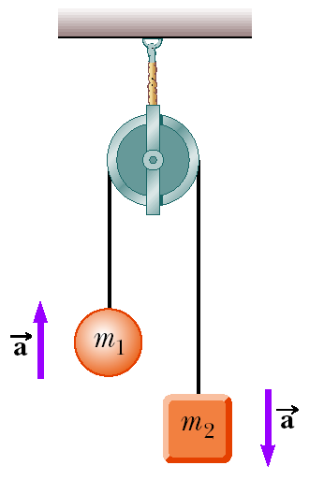
Figure P8.59

60. A 12.0-kg object is attached to a cord that is wrapped around a wheel of radius r = 10.0 cm (Fig. P8.60). The acceleration of the object down the frictionless incline is measured to be 2.00 m/s². Assuming the axle of the wheel to be frictionless, determine (a) the tension in the rope, (b) the moment of inertia of the wheel, and (c) the angular speed of the wheel 2.00 s after it begins rotating, starting from rest.

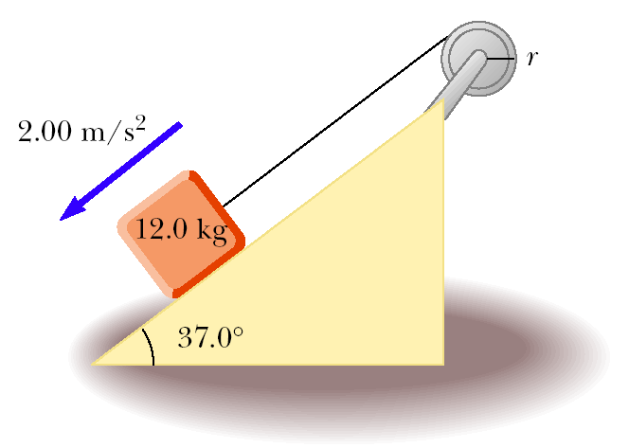
Figure P8.60

61. A uniform ladder of length L and weight w is leaning against a vertical wall. The coefficient of static friction between the ladder and the floor is the same as that between the ladder and the wall. If this coefficient of static friction is μ_{s} = 0.500, determine the smallest angle the ladder can make with the floor without slipping.

62. A uniform 10.0-N picture frame is supported as shown in Figure P8.62. Find the tension in the cords and the magnitude of the horizontal force at P that are required to hold the frame in the position shown.

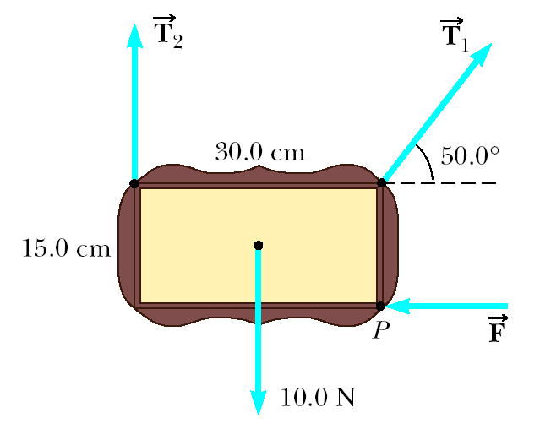
Figure P8.62
63. A solid 2.0-kg ball of radius 0.50 m starts at a height of 3.0 m above the surface of the Earth and rolls down a 20° slope. A solid disk and a ring start at the same time and the same height. The ring and disk each have the same mass and radius as the ball. Which of the three wins the race to the bottom if all roll without slipping?

64. A common physics demonstration (Fig. P8.64) consists of a ball resting at the end of a board of length $ℓ$ that is elevated at an angle θ with the horizontal. A light cup is attached to the board at r_{c} so that it will catch the ball when the support stick is suddenly removed. Show that (a) the ball will lag behind the falling board when θ < 35.3° and (b) the ball will fall into the cup when the board is supported at this limiting angle and the cup is placed at

$$r_{c}=\frac{2ℓ}{3\text{cos}θ}$$

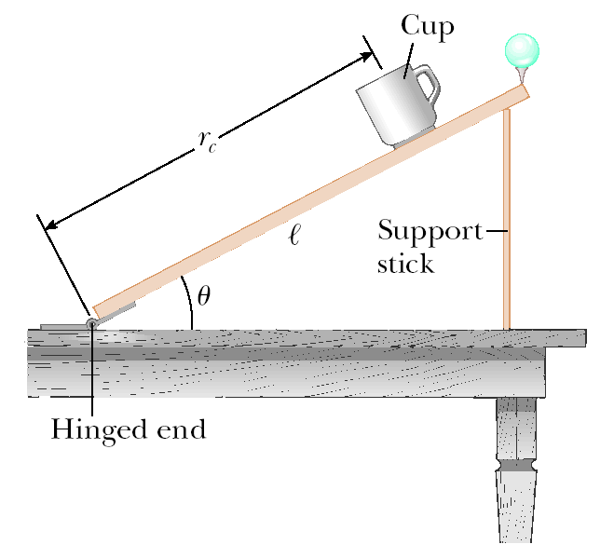
Figure P8.64

65. In Figure P8.65, the sliding block has a mass of 0.850 kg, the counterweight has a mass of 0.420 kg, and the pulley is a uniform solid cylinder with a mass of 0.350 kg and an outer radius of 0.0300 m. The coefficient of kinetic friction between the block and the horizontal surface is 0.250. The pulley turns without friction on its axle. The light cord does not stretch and does not slip on the pulley. The block has a velocity of 0.820 m/s toward the pulley when it passes through a photogate. (a) Use energy methods to predict the speed of the block after it has moved to a second photogate 0.700 m away. (b) Find the angular speed of the pulley at the same moment.

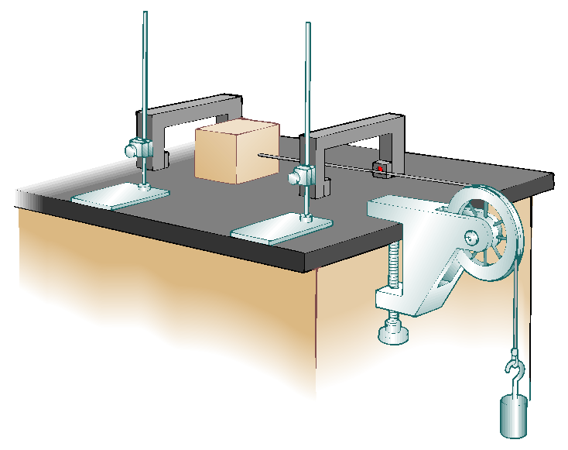
Figure P8.65

66. (a) Without the wheels, a bicycle frame has a mass of 8.44 kg. Each of the wheels can be roughly modeled as a uniform solid disk with a mass of 0.820 kg and a radius of 0.343 m. Find the kinetic energy of the whole bicycle when it is moving forward at 3.35 m/s. (b) Before the invention of a wheel turning on an axle, ancient people moved heavy loads by placing rollers under them. (Modern people use rollers, too: Any hardware store will sell you a roller bearing for a lazy Susan.) A stone block of mass 844 kg moves forward at 0.335 m/s, supported by two uniform cylindrical tree trunks, each of mass 82.0 kg and radius 0.343 m. There is no slipping between the block and the rollers or between the rollers and the ground. Find the total kinetic energy of the moving objects.
67. In exercise physiology studies, it is sometimes important to determine the location of a person’s center of gravity. This can be done with the arrangement shown in Figure P8.67. A light plank rests on two scales that read F_{g1} = 380 N and F_{g2} = 320 N. The scales are separated by a distance of 2.00 m. How far from the woman’s feet is her center of gravity?

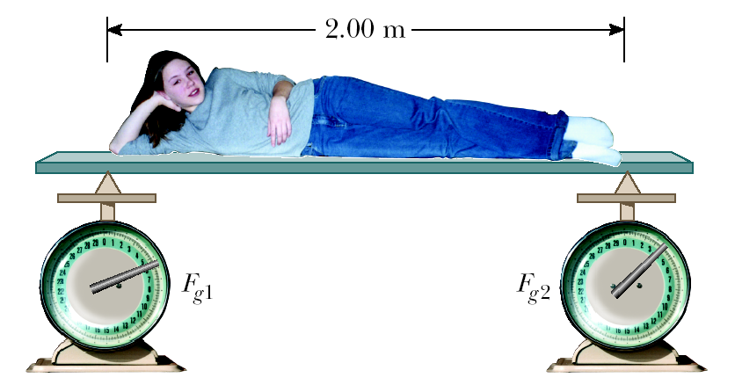
Figure P8.67

68. Two astronauts (Fig. P8.68), each having a mass of 75.0 kg, are connected by a 10.0-m rope of negligible mass. They are isolated in space, moving in circles around the point halfway between them at a speed of 5.00 m/s. Treating the astronauts as particles, calculate (a) the magnitude of the angular momentum and (b) the rotational energy of the system. By pulling on the rope, the astronauts shorten the distance between them to 5.00 m. (c) What is the new angular momentum of the system? (d) What are their new speeds? (e) What is the new rotational energy of the system? (f) How much work is done by the astronauts in shortening the rope?

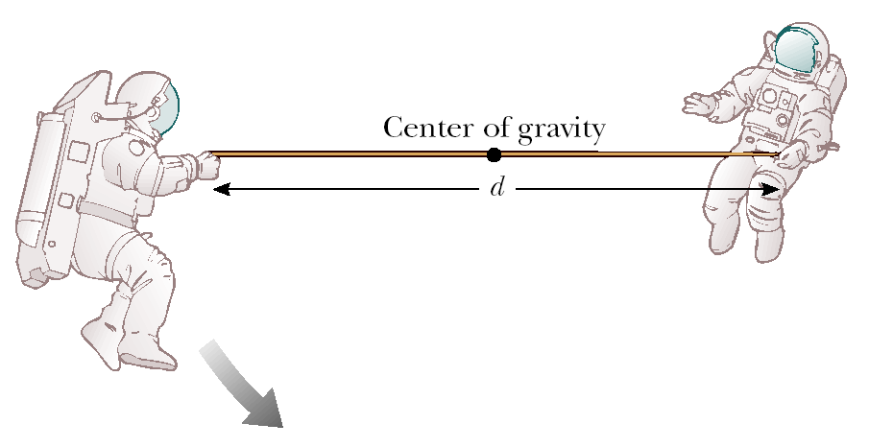
Figure P8.68 (Problems 68 and 69)

69. Two astronauts (Fig. P8.68), each having a mass M, are connected by a rope of length d having negligible mass. They are isolated in space, moving in circles around the point halfway between them at a speed v. (a) Calculate the magnitude of the angular momentum of the system by treating the astronauts as particles. (b) Calculate the rotational energy of the system. By pulling on the rope, the astronauts shorten the distance between them to d/2. (c) What is the new angular momentum of the system? (d) What are their new speeds? (e) What is the new rotational energy of the system? (f) How much work is done by the astronauts in shortening the rope?

70. Two window washers, Bob and Joe, are on a 3.00-m-long, 345-N scaffold supported by two cables attached to its ends. Bob weighs 750 N and stands 1.00 m from the left end, as shown in Figure P8.70. Two meters from the left end is the 500-N washing equipment. Joe is 0.500 m from the right end and weighs 1 000 N. Given that the scaffold is in rotational and translational equilibrium, what are the forces on each cable?

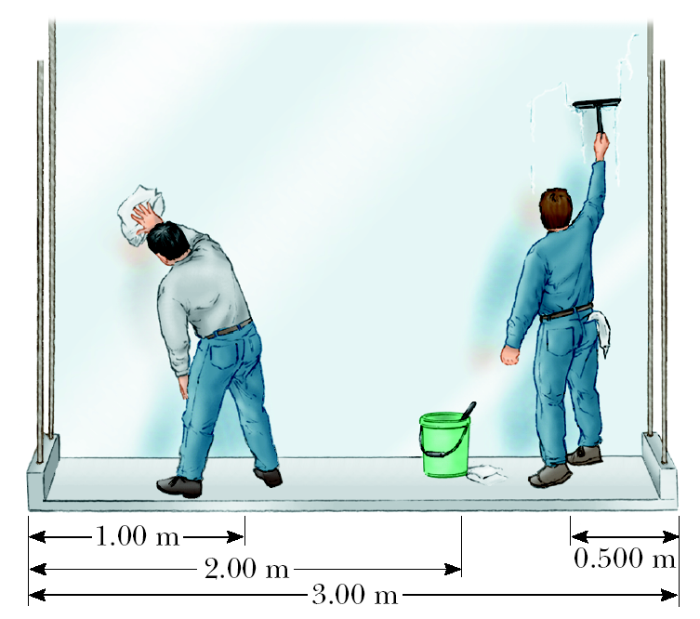
Figure P8.70

71. We have all complained that there aren’t enough hours in a day. In an attempt to change that, suppose that all the people in the world lined up at the equator and started running east at 2.5 m/s relative to the surface of the Earth. By how much would the length of a day increase? (Assume that there are 5.5 × 10⁹ people in the world with an average mass of 70 kg each and that the Earth is a solid, homogeneous sphere. In addition, you may use the result 1/(1 – x) ≈ 1 + x for small x.)

72. In a circus performance, a large 5.0-kg hoop of radius 3.0 m rolls without slipping. If the hoop is given an angular speed of 3.0 rad/s while rolling on the horizontal ground and is then allowed to roll up a ramp inclined at 20° with the horizontal, how far along the incline does the hoop roll?
73. A uniform solid cylinder of mass M and radius R rotates on a frictionless horizontal axle (Fig. P8.73). Two objects with equal masses m hang from light cords wrapped around the cylinder. If the system is released from rest, find (a) the tension in each cord and (b) the acceleration of each object after the objects have descended a distance h.

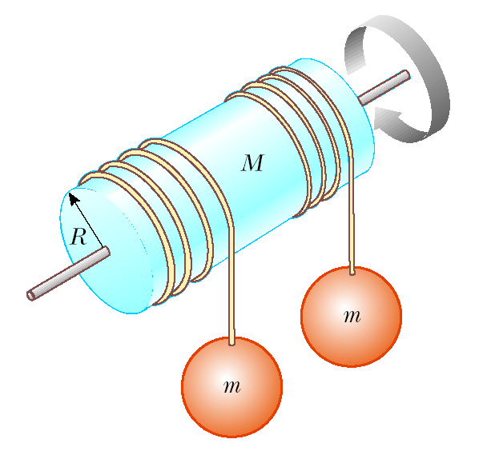
Figure P8.73

74. Figure P8.74 shows a vertical force applied tangentially to a uniform cylinder of weight w. The coefficient of static friction between the cylinder and all surfaces is 0.500. Find, in terms of w, the maximum force $\vec{F}$ that can be applied without causing the cylinder to rotate. [Hint: When the cylinder is on the verge of slipping, both friction forces are at their maximum values. Why?]

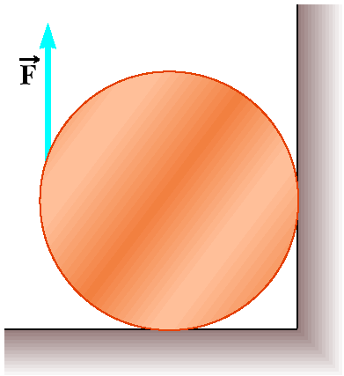
Figure P8.74

75. Due to a gravitational torque exerted by the Moon on the Earth, our planet’s period of rotation slows at a rate on the order of 1 ms/century. (a) Determine the order of magnitude of Earth’s angular acceleration. (b) Find the order of magnitude of the torque. (c) Find the order of magnitude of the size of the wrench an ordinary person would need to exert such a torque, as in Figure P8.75. Assume the person can brace his feet against a solid firmament.

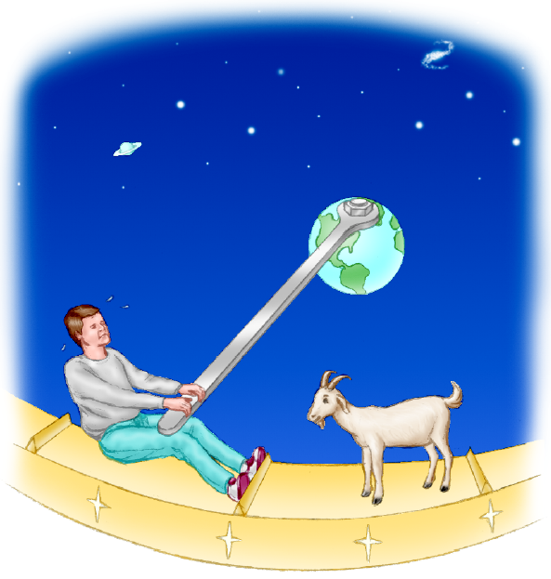
Figure P8.75

76. A uniform pole is propped between the floor and the ceiling of a room. The height of the room is 7.80 ft, and the coefficient of static friction between the pole and the ceiling is 0.576. The coefficient of static friction between the pole and the floor is greater than that. What is the length of the longest pole that can be propped between the floor and the ceiling?

77. A war-wolf, or trebuchet, is a device used during the Middle Ages to throw rocks at castles and now sometimes used to fling pumpkins and pianos. A simple trebuchet is shown in Figure P8.77. Model it as a stiff rod of negligible mass 3.00 m long and joining particles of mass 60.0 kg and 0.120 kg at its ends. It can turn on a frictionless horizontal axle perpendicular to the rod and 14.0 cm from the particle of larger mass. The rod is released from rest in a horizontal orientation. Find the maximum speed that the object of smaller mass attains.

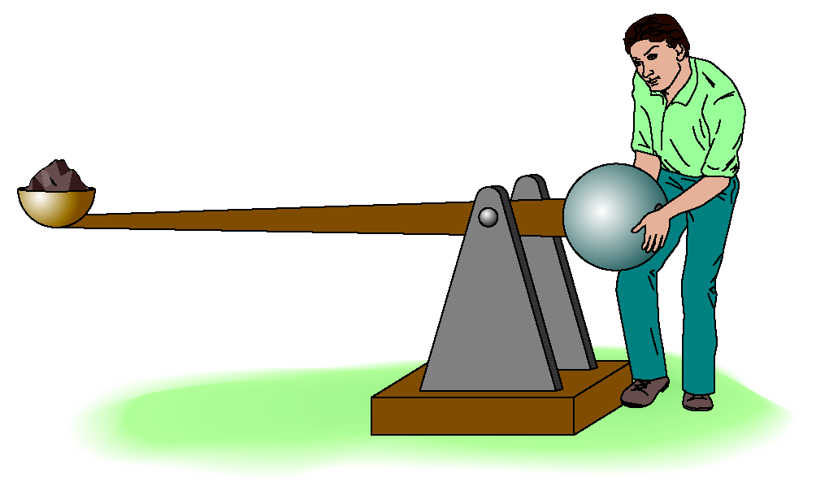
Figure P8.77

78. A painter climbs a ladder leaning against a smooth wall. At a certain height, the ladder is on the verge of slipping. (a) Explain why the force exerted by the vertical wall on the ladder is horizontal. (b) If the ladder of length L leans at an angle θ with the horizontal, what is the lever arm for this horizontal force with the axis of rotation taken at the base of the ladder? (c) If the ladder is uniform, what is the lever arm for the force of gravity acting on the ladder? (d) Let the mass of the painter be 80 kg, L = 4.0 m, the ladder’s mass be 30 kg, θ = 53°, and the coefficient of friction between ground and ladder be 0.45. Find the maximum distance the painter can climb up the ladder.

79. A 4.00-kg mass is connected by a light cord to a 3.00-kg mass on a smooth surface (Fig. P8.79). The pulley rotates about a frictionless axle and has a moment of inertia of 0.500 kg ∙ m² and a radius of 0.300 m. Assuming that the cord does not slip on the pulley, find (a) the acceleration of the two masses and (b) the tensions T₁ and T₂.

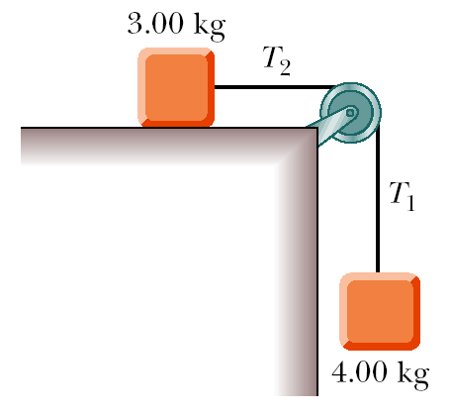
Figure P8.79

80. A string is wrapped around a uniform cylinder of mass M and radius R. The cylinder is released from rest with the string vertical and its top end tied to a fixed bar (Fig. P8.80). Show that (a) the tension in the string is one-third the weight of the cylinder, (b) the magnitude of the acceleration of the center of gravity is 2g/3, and (c) the speed of the center of gravity is (4gh/3)^{1/2} after the cylinder has descended through distance h. Verify your answer to (c) with the energy approach.

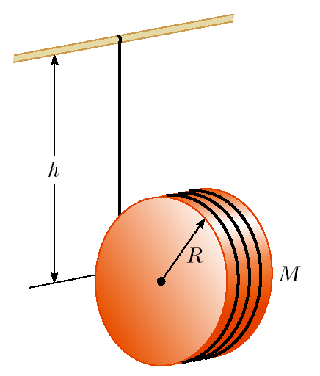
Figure P8.80

81. A person in a wheelchair wishes to roll up over a sidewalk curb by exerting a horizontal force $\vec{F}$ to the top of each of the wheelchair’s main wheels (Fig. P8.81a). The main wheels have radius r and come in contact with a curb of height h (Fig. P8.81b). (a) Assume that each main wheel supports half of the total load, and show that the magnitude of the minimum force necessary to raise the wheelchair from the street is given by

$$F=\frac{\text{mg}\sqrt{2\text{rh}−h^{2}}}{2\left(2r−h\right)}$$

where mg is the combined weight of the wheelchair and person. (b) Estimate the value of F, taking mg = 1 400 N, r = 30 cm, and h = 10 cm.

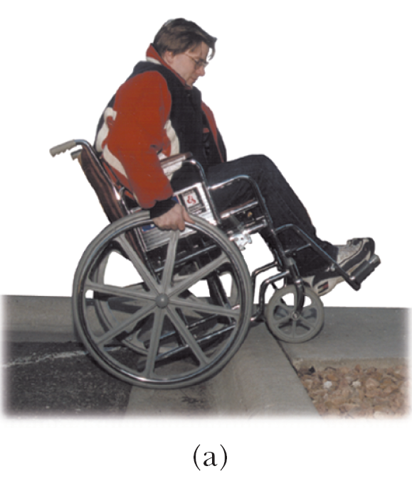
Figure P8.81

82. The truss structure in Figure P8.82 represents part of a bridge. Assume that the structural components are connected by pin joints and that the entire structure is free to slide horizontally at each end. Assume furthermore that the mass of the structure is negligible compared with the load it must support. In this situation, the force exerted by each of the bars (struts) on the pin joints is either a force of tension or one of compression and must be along the length of the bar. Calculate the force in each strut when the bridge supports a 7 200-N load at its center.

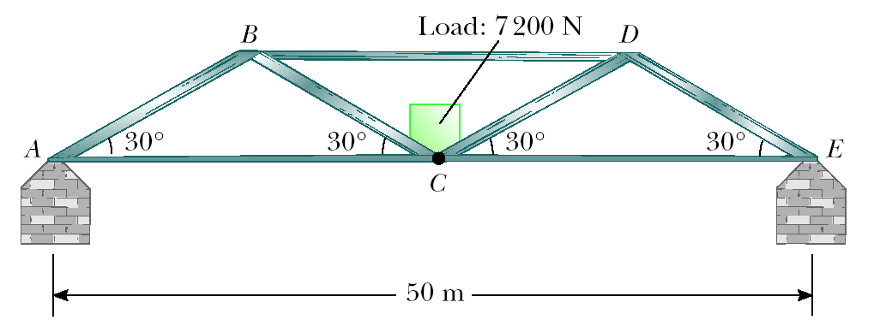
Figure P8.82
83. The Iron Cross When a gymnast weighing 750 N executes the iron cross as in Figure P8.83a, the primary muscles involved in supporting this position are the latissimus dorsi (“lats”) and the pectoralis major (“pecs”). The rings exert an upward force on the arms and support the weight of the gymnast. The force exerted by the shoulder joint on the arm is labeled ${\vec{F}}_{s}$ while the two muscles exert a total force ${\vec{F}}_{m}$ on the arm. Estimate the magnitude of the force ${\vec{F}}_{m}$. Note that one ring supports half the weight of the gymnast, which is 375 N as indicated in Figure P8.83b. Assume that the force ${\vec{F}}_{m}$ acts at an angle of 45° below the horizontal at a distance of 4.0 cm from the shoulder joint. In your estimate, take the distance from the shoulder joint to the hand to be 70 cm and ignore the weight of the arm.

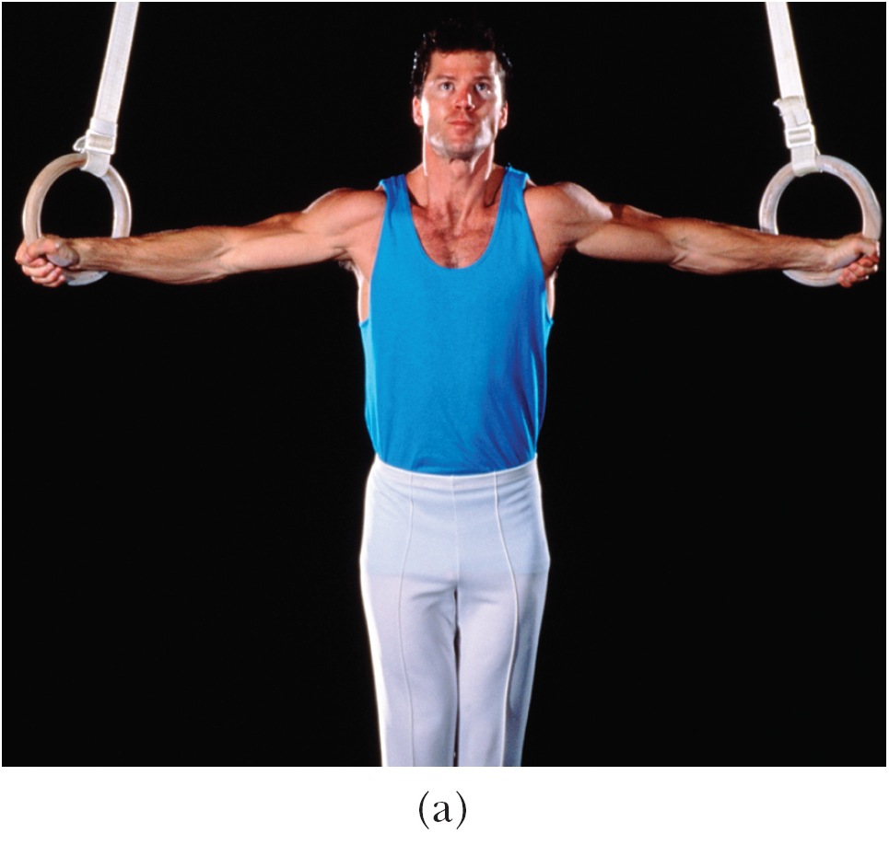
© Ed Bock/Corbis
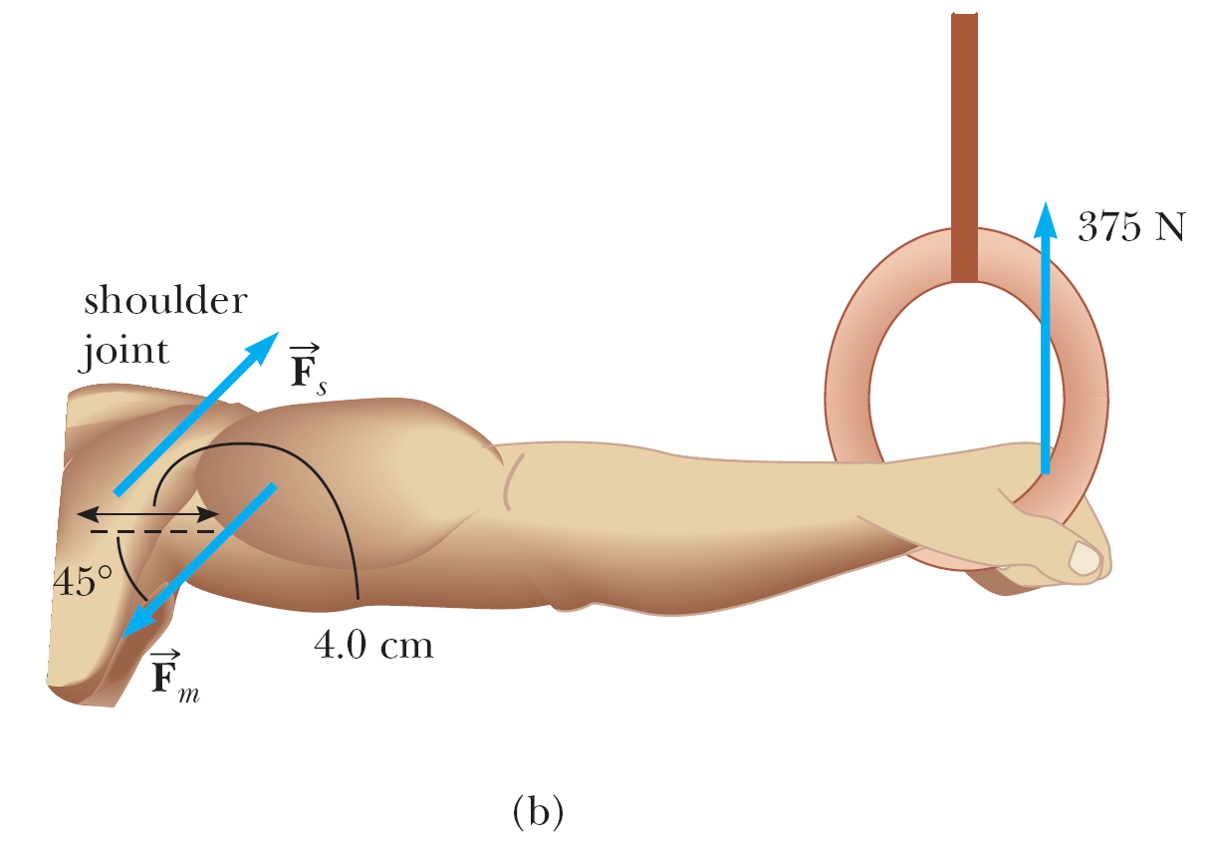
Figure P8.83
84. Swinging on a high bar The gymnast shown in Figure P8.84 is performing a backwards giant swing on the high bar. Starting from rest in a near-vertical orientation, he rotates around the bar in a counterclockwise direction, keeping his body and arms straight. Friction between the bar and the gymnast’s hands exerts a constant torque opposing the rotational motion. If the angular velocity of the gymnast at position 2 is measured to be 4.0 rad/s, determine his angular velocity at position 3. (Note that this maneuver is called a backwards giant swing, even though the motion of the gymnast would seem to be forwards.)

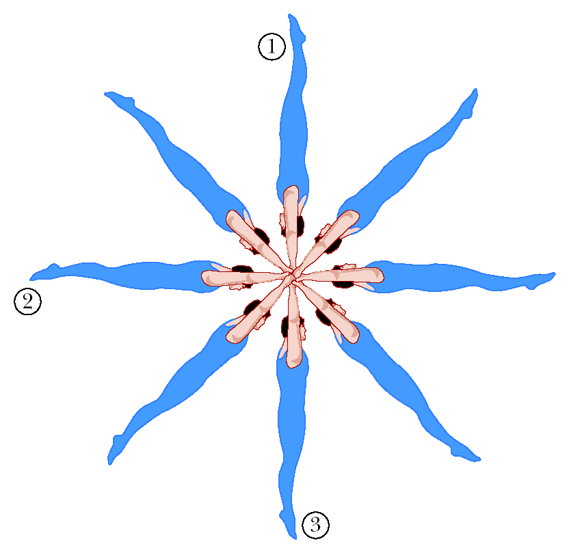
Figure P8.84

© Copyright 2004 Thomson. All rights reserved.

